APPENDIX 1 Procedures for reporting a child that is Absent, Away from Placement without authorisation, Missing or Absconder (unlawfully at large)

Instances of absences should be reported to the Police. There will be an agreement with the person reporting the episode a future course of action e.g. the police to be informed should the child or young person not return in a specified time period.
If Missing contact Police and complete police F36 and if possible email or fax the F36. Inform the police that the protocol risk assessment has been used.

Police will use information from the protocol risk assessment to inform the police risk assessment process

Allocated for investigation
Child located
Return interview carried out within 72 hours
Communication is to be maintained at all times as any reasonable parent would do. If there is new information or the child returns make sure the police the responsible and host authorities are informed.

If Absconder (unlawfully at large) must report to Police immediately

If children placed out of their local authority run away the host local authority Missing Protocol should be followed. A notification process for missing/absent episodes should be in place between the responsible and host local authorities

Safe and well check carried out by police
Report to own organisation Record all relevant information
Parent/carer/social worker/residential staff to undertake search of property, locations and contact friends and family
Use the Risk Assessment within the protocol to determine is it Absent / Away from Placement/ Missing or Absconder

Child/ young person goes missing from home or care
If missing must report to Police immediately

If away from placement the responsibility remains with carer or residential staff. Continued review of risk will be undertaken

Social workers and IRO’s should be informed of all absence, away from placement without authorisation and missing episodes
APPENDIX 2 LOCAL AUTHORITY MISSING FROM CARE RISK ASSESSMENT

Risk assessment: for children and young people who run away from care or are at
risk of becoming missing from care.
(The risk indicators can also be used to inform assessments for children and young
people who run away or are at risk of running away from home.)

Name of child or young person:................................................................. ID:......................
Date of Birth: ............................. Age:........... Legal Status: .........................................

It is important in completing this risk assessment that you consider the definitions of missing and absent being used are:

Missing – “Anyone whose whereabouts cannot be established and where the circumstances are out of character, or the context suggests the person may be subject of crime or at risk of harm to themselves or another. “

Absent – “A person not at a place where they are expected or required to be”.

The risk indicators should prompt the assessment and any relevant information, which should be included under the section "risk assessment information".
Risk indicators | Risk assessment information
What are the usual circumstances of the child/young person going missing i.e. is the young person running to someone or from a situation? When does the child/young person usually leave the home?
Where do they usually go? Are they with family or friends or with people who are unknown or undesirable?
What level of maturity has the young person shown in being able to make decisions about themselves or others?
What are the agreed coming in times, if any?
Do they have access to any money and how if necessary will they obtain this?
Are there any known issues/events happening in the child’s/young person’s family or close friends?
Past method of return i.e. via family or on their own
What is the risk of suicide/self-harm? What are the indicators of this?
Likely use of drugs/alcohol/solvents? If so, type and amount?
Past involvement of offending and in what form? Is the child/young person a risk to the community and in what way?

Risk indicators | Risk assessment information
Is there risk of sexual exploitation?
Have sexual exploitation protocols been activated (e.g. CSE strategy meetings)?
Any previous harm suffered while absent?
Any concerns about new friends /boyfriends/associates?
Any concern of abduction or being prevented from returning?
Is there a risk of forced marriage?
Are they experiencing bullying/racial and/or homophobic abuse?
Any signs or indicators that child is experiencing difficulties or abuse in the placement?
Is the child/young person on medication or suffering from medical condition?
Physical or learning disability/difficulties?
What is the child/young person’s legal status?
Any further information and knowledge

This risk assessment grid above should be used as a guide and involve discussion and pooling of information to agree an informed risk assessment. In cases of little knowledge or where there is disagreement, the child or young person should be considered as being at higher risk.

Concluding risk assessment

Action to be taken by whom and by when (in bullet points)

Young Person ………………………………………… Date………………………..
RCCW/Foster Carer………………………………………………Date………………………..
Home Manager/Family Placement Worker………………………………………………. Date………………………...

Categories of absence: for children and young people who run away from care

Unauthorised absence | Usual action
Absent – “A person not at a place where they are expected or required to be”. | 1. Carry out a MFH risk assessment or refer to MFH already in place  2. Make enquiries to locate the child/young person and search premises  3. Inform the police and agree any future course of action.  4. Inform/contact family and those with parental responsibility.  5. Where action not already agreed in MFH risk assessment is available Inform and discuss with on call manager and or social worker/Emergency Duty Team.  6. Where child/young person has not returned undertake action as agreed with the police  7. Once child/young person has been missing for longer than the agreed period follow-on action needs to be agreed.
Missing | Usual action
Missing – “Anyone whose whereabouts cannot be established and where the circumstances are out of character or the context suggests the person may be subject of crime or at risk of harm to themselves or another. “ | 1. Carry out a risk assessment  2. Make enquiries to locate the child/young person and search premises.  3. Inform on-call manager/senior.  4. Report child/young person missing to the police providing full details  5. Inform/contact family and those with parental responsibility  6. Inform/discuss with social worker/Emergency Duty Team
Unlawfully at large | Usual action
A child is considered unlawfully at large when they are absent from their placement without permission and are subject to an order or requirement resulting from the criminal justice system | 1. Carry out a risk assessment  2. Make enquiries to locate the child/young person search premises.  3. Inform on-call manager/senior.  4. Report child/young person missing to the police providing full details.  5. Inform/contact family and those with parental responsibility.  6. Inform and discuss with social worker/ Emergency Duty Team  7. Inform Youth Offending Service/probation/legal as appropriate.

Unauthorised absence– lower risk | Missing /unlawfully at large– higher risk

Signature of staff member PRINT NAME
...............................................................................................................................................

Date and time: ......................................................................................................................

Signature of line manager: PRINT NAME ……………………………………………………….

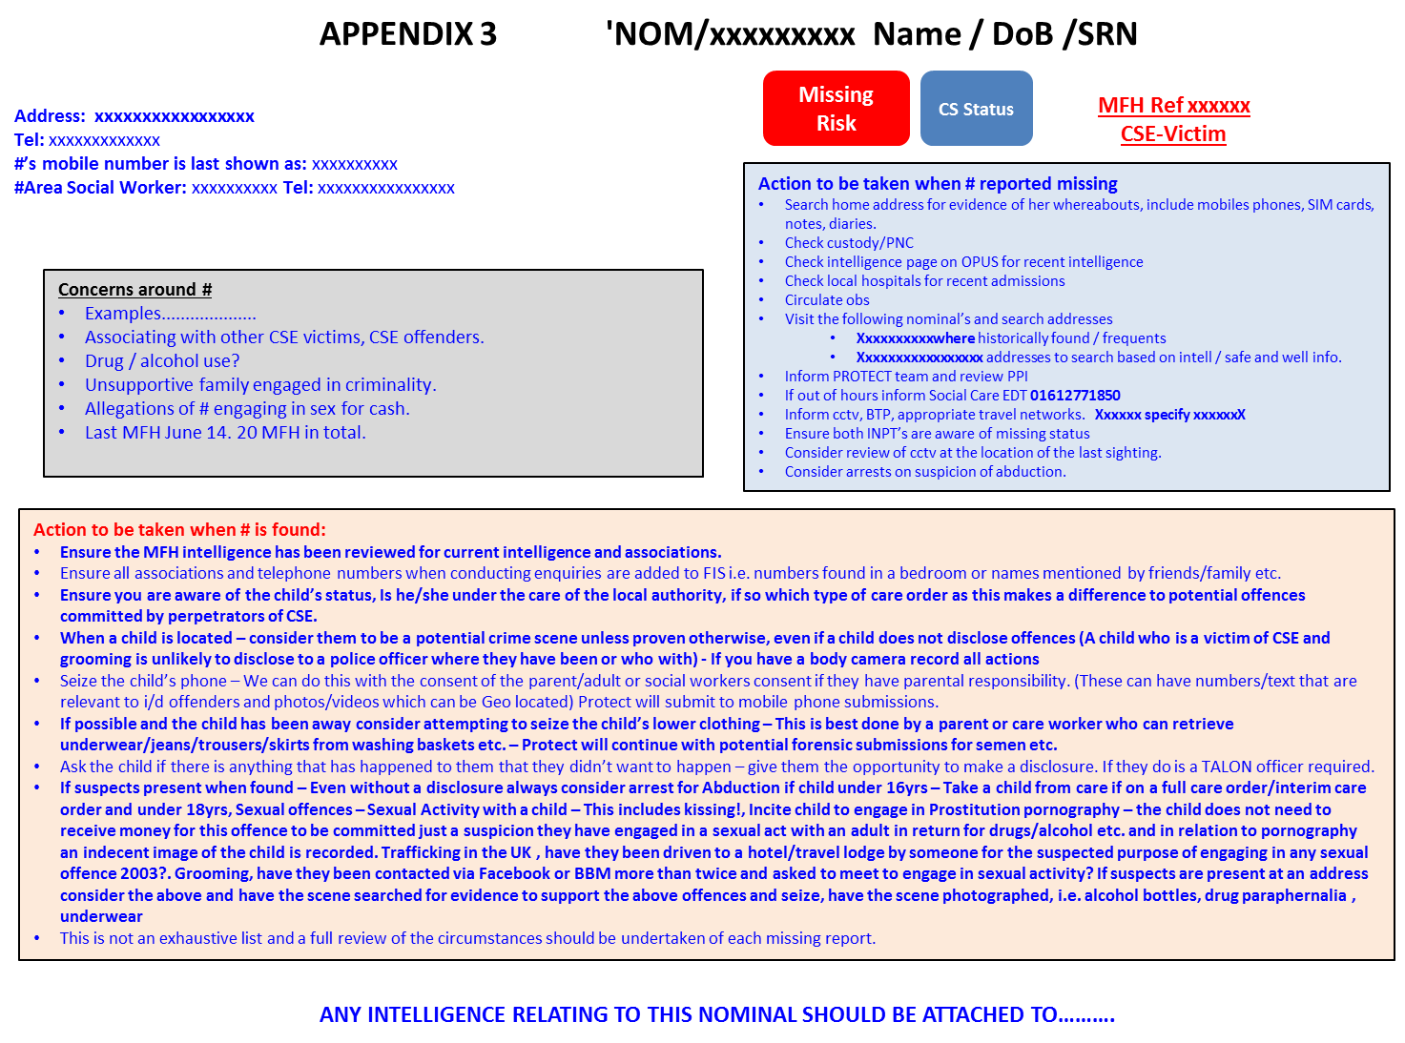
APPENDIX 4 FORM 36 REPORT OFMISSING / FOUND PERSON

HIGH RISK MISSING PERSON

MEDIUM RISK MISSING PERSON

LOW RISK MISSING PERSON

MISSING CHILD or YOUTH (Under 18 Years). LOOKED AFTER BY LOCAL AUTHORITY

MISSING CHILD or YOUTH (Under 18 Years)

FOUND ADULT

FOUND CHILD

FOUND BODY

ABSCONDER FROM LOCAL AUTHORITY CARE

ABSCONDER FROM HOSPITAL (Record here Mental Health Act, Section……………. and

Expiry date for Mental Health Act 1983 Order ………………………..

Date of Initial Report
Incident No.
Reporting Officer
Force / Station Code
Case Reference No.
SECTION 1 IDENTITY / DESCRIPTION DETAILS (Use BLOCK capitals)
Surname…………………………………………………………………………………………………
Forename(s)……………………………………………………………………………………….. …
Date of Birth………………………………………………………………………………………………………
Gender……………………………………………………………………………………………………

School / Occupation………………………………………………………………………………

SECTION 2 PERSONAL DETAILS

Place of Birth………………………………………………………………………………….
Nationality……………………………………………………………………………………
Other Name(s) Used…………………………………………………………………………
Maiden Name………………………………………………………………………………..

Nickname(s) / Alias (es)………………………………………………………………………
Address from which missing…………………………………………………………………
………………………………………………………………………………………………….
Home Address if different from above. ……………………………………………………
…………………………………………………………………………………………………
Section 3 PERSONAL DETAILS

Ethnic Appearance:
- White European / 3. Afro Caribbean / 5. Oriental / 2. Dark European / 4. Asian / 6. Arab / 0. Unknown
Features:
Height: ……………………..
Marks / Scars / Tattoos / Body Piercings (visible when clothed)....................................
……………………………………………………………………………………………………
……………………………………………………………………………………………………
Marks / Scars / Tattoos / Body Piercings (normally concealed beneath clothing)
…………………………………………………………………………………………………………….
……………………………………………………………………………………………………………………………………………………………………………………………………………………………..
Complexion………………………………………………………………………………………………
Build………………………………………………………………………………………………………
Sideburns…………………………………………………………………………………………………..
Colour of Eyes.…………………………………………………………………………………………….
Eyesight Correction (where applicable) ……………………………………………………………..
Description of Spectacles ……………………………………………………………………………
Contact Lenses Worn : YES / NO
Beard ……………………………………………………………………………………………
Moustache………………………………………………………………………………………
Peculiarities (Limp, Stammer, Other Disabilities)
Hair:
Length ……………………………………………………………………………………………
Colour(s) …………………………………………………………………………………………
Hair Style (Description) …………………………………………………………………………

Recent Photo

SECTION 4 CLOTHING
Shirt / Sweater ……………………………………………………………………………………………
Trousers …………………………………………………………………………………………………
Outer Wear ………………………………………………………………………………………………
Underwear………………………………………………………………………………………………….
Head Wear ………………………………………………………………………………………………
Gloves Other Clothing………………………………………
Footwear …………………………………………………………………………………………………

SECTION 5 JEWELLERY
Pierced Ears: YES / NO
Ear Rings (Description) …………………………………………………………………………………
Other Body-piercing Jewellery (Description)…………………………………………………………
………………………………………………………………………………………………………………
………………………………………………………………………………………………………………
Watch (es) ………………………………………………………………………………………………..
Bracelet(s) …………………………………………………………………………………………………
Rings ……………………………………………………………………………………………………
Necklace(s) ………………………………………………………………………………………………
Other ……………………………………………………………………………………………………..

SECTION 6 CIRCUMSTANCES UNDER WHICH MISSING
Last Seen: Time Date …………………………………………………
Where? ……………………………………………………………………………………………………
By? ………………………………………………………………………………………………………
Who talked with misper? ………………………………………………………………………………
What was discussed? ………………………………………………………………………………………………….
…………………………………………………………………………………………………………
………………………………………………………………………………………………………………

Misper seen going which way? …………………………………………………………………………………………………………
…………………………………………………………………………………………………………

Reason for leaving? ……………………………………………………………………………………………………..

………………………………………………………………………………………………………………

………………………………………………………………………………………………………………

Attitude (confident / confused, etc.) ……………………………………………………………………

……………………………………………………………………………………………………………..
Misper complaining of anything? ………………………………………………………………………

………………………………………………………………………………………………………………
………………………………………………………………………………………………………………
Other comments concerning misper ……………………………………………………………………
………………………………………………………………………………………………………………
General Health ………………………………………………………………………………………………………………
Factors for Concern (Medication, Drugs, Dressed, Suicidal, Violent, etc)
………………………………………………………………………………………………………………
………………………………………………………………………………………………………………
Consequences of missed medication …………………………………………………………………………………………………………….
………………………………………………………………………………………………………………
………………………………………………………………………………………………………………

SECTION 7 OTHER RELEVANT INFORMATION

Medical Information:
Doctor ………………………………………………………………………………………………..
Address …………………………………………………………………………………………………
Telephone No………………………………………………………………………………………….
Dentist…………………………………………………………………………………………………...
Address …………………………………………………………………………………………………
Telephone Number ………………………………………………………………………………………
Finance:
Money in possession of misper ………………………………………………………………………
Bank 1 Telephone No …………………

Account Number ………………………………………
Bank 2 Telephone No…………………

Account Number ………………………………………

Credit Cards:
Company 1 …………………………………………………………………………………………………………

Account Number ………………………………………… Telephone Number ………………..

Company 2 …………………………………………………………………………………………………………

Account Number ……………………………………… Telephone Number …………………….

Vehicle Access by misper:
Make ………………………………Model ……………………….. VRM ………………………

Colour ………..

Other distinguishing features …………………………………………………………………………..

………………………………………………………………………………………………………………

Location Now …………………………………………………………………………………………………………

SECTION 8 ADDITIONAL INFORMATION
(HABITS / PLACES FREQUENTED, ETC)

………………………………………………………………………………………………………………

………………………………………………………………………………………………………………

………………………………………………………………………………………………………………

………………………………………………………………………………………………………………

SECTION 9 INFORMANT DETAILS

Surname ………………………………………………………………………………………………………………

Forename ………………………………………………………………………………………………………………

Telephone Nos: Home ……………………………………………. Work ……………………………

Mobile …………………………………………………Other ……………………………………………

Relationship ……………………………………………………………………………………………

Next of Kin …………………………………………………………………………………………………

Contact: Address / telephone …………………………………………………………………………

………………………………………………………………………………………………………………

Relationship ………………………………………………………………………………………………

Person to Notify when missing person found …………………………………………………………

……………………………………………………………………………………………………………

Publicity: The informant should be informed of the possible use of the media in assisting in attempt to trace the missing person.

National Missing Persons Helpline Pamphlet issued: YES / NO

SECTION 10 CONSENT TO ACCESS RECORDS

I consent to the Cheshire Constabulary, in investigating the disappearance of the person named in this report, to make any necessary enquiries with the named doctor / dentist / educational establishment / workplace / financial or other agency, or their representative, and examine, take, copy and retain any material considered relevant to the enquiry : YES / NO

Date ………………………………………………………………………………………………………

Name ……………………………………………………………………………………………………

Signature ………………………………………………………………………………………………

Relationship to misper ………………………………………………………………………………

