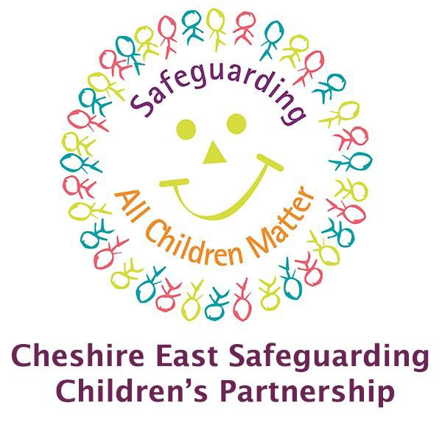
CHESHIRE EAST NEGLECT SCREENING TOOL

Definition of Neglect

Neglect is ‘The persistent failure to meet a child’s basic physical and/or psychological needs, likely to result in the serious impairment of the child’s health or development. Neglect may occur during the pregnancy as a result of maternal substance abuse. Once a child is born, neglect may involve a parent or carer failing to: provide adequate food, clothing or shelter (including exclusion from home or abandonment); protect a child from physical and emotional harm or danger, ensure adequate supervision (including the use of inadequate caregivers); ensure access to appropriate medical care or treatment. It may also include neglect of, or unresponsiveness to, a child’s basic emotional needs.’ (Working Together to Safeguard Children 2018)
Neglect occurs at every socioeconomic level, across ethnic and cultural lines, within all religions and at all levels of education. It is important for you to know and understand the family’s religion, culture and community and the impact this may have on the care given to the child and to avoid judgements that are not appropriate.

Signs of Neglect

The tool lists possible signs of Neglect however the list is not exhaustive but may include;

- Appearing unkempt

- Lack of supervision

- Failure to attend health appointments

- Hungry at school

Purpose of Tool

Is to equip frontline practitioners to:

  - identify signs of neglect at an early stage,
  - alert the need for further action
  - Identify which agency/organisation/practitioner will progress further assessment/intervention as needed.

Child Protection / Safeguarding Statement

This screening tool does not replace Cheshire East’s and/or your own safeguarding policy and procedures in cases where you are concerned that a child/young person has been or is at risk of immediate harm. You should be clear whether you are using this tool as a member of staff only to assist your professional thinking, or jointly with the family to explore, share and discuss issues of concern. Using the tool to assist professional thinking should not deter members of staff from engaging in open and honest communication with families about identified concerns.
It will not be necessary in every case to refer on. Providing advice and guidance to a child, young person and/or family to address the concerns may be adequate in some cases.

If there are wider concerns, consider the need for multi-agency planning and intervention and use the normal referral pathway. Maintain ongoing review of risk and re-screen if necessary.

If concerned about Neglect, then speak to your Designated Safeguarding Lead within your organisation. If you are worried that a child is at immediate risk of significant harm consult with CHECS. Tel: 0300 123 5012 option 3.

Using the tool

The tool is intended for front line practitioners within all partner agencies as a means to quickly identify areas of concern which may indicate a child/young person is being neglected. It is intended to complement existing tools E.G Early help assessment. Child Exploitation (CE) or other screening/assessment tools and should be used accordingly. The tool is designed to aid professional thinking in conjunction with Signs of Safety and is intended to be applicable to all ages of children; it should help you identify Neglect and associated factors across all age ranges. Completing the tool will not automatically mean children’s social care will need to get involved.
In order to complete this tool, it is essential that you are able to evidence the reasons why you have highlighted concerns for any of the factors indicated. Only complete the parts of the tool you are certain about. If you are unsure about completing the assessment seek appropriate help within your organisation. It is essential that where you have highlighted areas of the assessment where you are very concerned or sometimes concerned that you provide further information to evidence these concerns.

Neglect Screening Procedure

Neglect identified by professional/agencies
Complete CESCP Neglect Screening Tool
Provide information and advice to parent/carer and identify what support you can offer
Consideration should be given to arranging an Early Help Assessment to address the concerns about Neglect

If concerns remain and following discussion with your designated lead if possible, consult with Cheshire East Consultation Service (CHECS) Tel: 0300 123 5012 option 3.

Identifying details

Name |  | Next of Kin
Date of birth or EDD |  | Contact tel. no.

Address

Have you discussed your concerns with parent/carer? YES/NO

If the answer is no, please provide additional information.

Does the child have any additional needs? YES/NO

If yes, please give details

Name of practitioner/agency Date completed form

Neglect screening tool adapted from Child Abuse Review 2008 | Very concerned | Sometimes | Not concerned
Category: Emotional and behaviour
Relationships with peers/support networks are poor
Child/young person feels or is excluded by family
Evidence of emotional withdrawal
Attachment disorder: anxious, avoidant, socially unresponsive
High criticism, low warmth from parent/ carer
Non biological partner appears to resent the child/young person
Child/young person seeks inappropriate physical comfort from others
Under-stimulation evident, the child has no toys or inappropriate toys, books games etc.
Lack of online supervision, exposed to inappropriate films, websites, games or materials
Shows reluctance to go home
Self-harm
Episodes of missing or running away
Child/young person has Inappropriate carer responsibilities for other family members
Category; Environmental factors
Human and animal excrement present around the home. Animals pose a level of risk
Unsafe unhygienic home environment
Little or no bedding/furniture
Rural isolation/Poverty
Poor housing
Unidentified adults or young people in the home

Inadequate supervision
Neglect screening tool adapted from Child Abuse Review 2008 | Very concerned | Sometimes | Not concerned
Category; Health/physical care
Frequent attendance at A&E and/or hospital admission
Poor weight gain/nutrition or obesity
Untreated or persistent head lice or other untreated health condition
Refusing help/services
Poor personal hygiene of child/young person
Substance abuse of child/adult/household member
Continuously failing appointments, not addressing health needs/treatments
Inappropriately dressed for time of year clothes are not clean and do not fit.
Not Registered with a G.P, not seeking support when the child is unwell or requires specific care (disability)
Dental hygiene poor/not registered with a dentist
Category; Parenting
Poor/ no family support, no other support network
Inappropriate language/poor boundaries for own behaviour
Fails to give appropriate routines, no boundaries for behaviour
Parental mental ill health is causing concern
Parents/carers are not able or are not working with the plan, the support network or professionals
Aggressive or threatening behaviour towards professionals
Leaving children with inappropriate carers/babysitters

Little or no planning for the child, family life is disorganised/chaotic
Unrealistic expectations of child/ young person, there are too many rules.
Parent carer relationships are abusive or violent (domestic abuse)
Neglect List for screening tool adapted from Child Abuse Review 2008 | Very concerned | Sometimes | Not concerned
Category; Education
Unexplained declining or non-attendance at nursery/school/college
Child/young person is not achieving academic potential
Inadequately prepared for nursery/school/college
Lack of parental/carer engagement with nursery/school/college
Withdrawn/lethargic. Frequently tired or unable to concentrate
Unexplained extremes of behaviour
Category: Feeding and eating
Little or no food in cupboards
Stealing/scavenging/ hoarding food
Presents at nursery/school/ college as unusually hungry
Frequently does not seem to have a balanced diet or enough to eat
Inadequate area to prepare food

Summary
What is working well?

What are you worried about?

What is the child/young person’s view of their situation? (If the child is too young to express their views what are your observations of the child within the family setting?)

What are the parents’/carers’ views of the situation for the child?

What needs to happen?

Who is going to do what?

Can you provide the additional service needed? Yes No

Have you identified actions? Yes No

If you answered ‘no’ or ‘not sure’ to any of the previous questions, or it is not clear what support is needed, would an assessment using the Graded Care Profile help? Yes No

If you answered ‘Yes’ to the previous question, who will do this assessment?

I will Another practitioner will

