Cheshire East Safeguarding
Children’s Partnership

Multi-Agency
Assessment
Toolkit

Welcome to the CE SCP Guide to MULTI-AGENCY SCREENING TOOLS
Table of Contents
INTRODUCTION 3
WHO SHOULD USE THIS MULTI AGENCY ASSESSMENT TOOLKIT? 3
CAPTURING THE VOICE OF THE CHILD 4
WHAT MAKES A GOOD ASSESSMENT? 4
WHY IS IT NEEDED? 5
THE TOOLS INCLUDED 5
EARLY HELP 6
NEGLECT 6
NEGLECT SCREENING TOOL 6
GRADED CARE PROFILE 2 6
CONTEXTUAL SAFEGUARDING 8
SCREENING TOOL 8
CONTEXTUAL SAFEGUARDING ASSESSMENT TOOL 9
CHILD SEXUAL BEHAVIOUR 9
RESILIENCE AND VULNERABILITY MATRIX 10
MULTIPLE SAFEGUARDING STRESSORS (TOXIC TRIO) 10
DOMESTIC ABUSE 11
SUBSTANCE MISUSE 12
ALCOHOL MISUSE 12
ADULT MENTAL HEALTH 13

INTRODUCTION
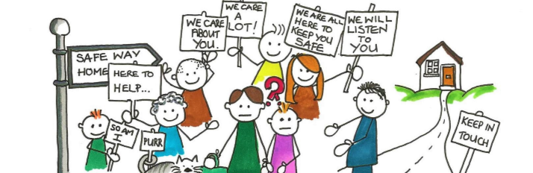
It is vital that children and young people receive the right service at the right time. Practitioners decision making, needs to be led by evidenced based screening and assessment of what the child is experiencing and the impact on them of carers behaviour. This approach is supported by Working Together 2018. For this to happen, all professionals who have contact with children, young people and families have a responsibility to recognise issues as early as possible and assess whether intervention is required.

Assessment should be a dynamic process that identifies analyses and responds to the changing nature and level of need and/or risk faced by a child. Continuous assessment is crucial in ensuring that the help and support being delivered is having the intended impact.

This multi-agency assessment toolkit has been developed to support practitioners to undertake effective assessments that enable them to accurately identify appropriate cases in need of early help or onward referral to Children’s Social Care. The tools included should also be used to review the effectiveness of the support plans that are in place and the outcomes for the child/ren.

Using the assessments early in intervention will hopefully support positive outcomes for children, meaning onward referral may not be required. However, should a case need referral, professionals will be expected to evidence why a threshold has been met despite appropriate intervention. The assessments included in the toolkit will provide a record of evidence for this purpose.

Completion of the relevant assessments and screening tools is therefore an important part of any referral to the Cheshire East Consultation Service (ChECS), Child and Adolescent Mental Health Team (CAMHS) and Commissioned Services.

WHO SHOULD USE THIS MULTI AGENCY ASSESSMENT TOOLKIT?
These tools are available for any services, schools or organisations who work with children and families in Cheshire East. All professionals need to be familiar with the tools provided and know when and how to use them. Managers should facilitate practitioner’s attendance at relevant training events to support the use of these tools and seek assurance in supervision/ safeguarding lead that they are completed where appropriate. The tools should be shared with parents and the child (where appropriate) and where possible, their views recorded. The appropriate tool should inform what action you need to take as agency and underpin any referral for support to another agency including ChECS. The only circumstance for not completing the right assessment tool is where the delay would be a risk for a child.

CAPTURING THE VOICE OF THE CHILD
It is important when completing any assessments that the wishes and feelings of the child are listened to throughout. Professionals need to ensure the voice of the child runs through everything we do. The voice of the child is of paramount importance in testing out whether the apparent outcomes of interventions are having the desired impact for them. Seeking the views of the child will ensure that there is not over reliance on parental accounts which can therefore minimise the risk of disguised compliance.

This can be done by:
- Direct engagement
- Observation
- Discussion with parents, family members, carers or agencies
- Analysis of information held to consider what the impact might be on the child

Where possible and appropriate to the age/understanding of the child the tools should be used with the children as well as the adults in the family.

Guidance on using signs of safety (cescp.org.uk)

WHAT MAKES A GOOD ASSESSMENT?
Good assessment matters and is key to effective intervention and to improving outcomes for children. Significant decisions are made because of professional assessments that affect outcomes for children in both the short and long term.

A robust assessment will identify, analyse and respond to the changing nature and level of need and/or risk faced by a child, allowing practitioners to offer the right support at the right time, evaluate change and monitor and record the impact of any services delivered to the child and family. Holistic assessments will include strengths as well as areas for development within the family and will consider the child’s wishes for the future.

The 2018 Working Together guidance states ‘Assessment should be a dynamic process, which analyses and responds to the changing nature and level of need and/or risk faced by the child from within and outside their family. It is important that the impact of what is happening to a child is clearly identified and that information is gathered, recorded and checked systematically, and discussed with the child and their parents/carers where appropriate’

They list these key factors of a high-quality assessment
- are child centred. Where there is a conflict of interest, decisions should be made in the child’s best interests: be rooted in child development: be age-appropriate; and be informed by evidence
- are focused on action and outcomes for children
- are holistic in approach, addressing the child’s needs within their family and any risks the child faces from within the wider community
- ensure equality of opportunity
- involve children, ensuring that their voice is heard and provide appropriate support to enable this where the child has specific communication needs
- involve families
- identify risks to the safety and welfare of children
- build on strengths as well as identifying difficulties
- are integrated in approach
- are multi-agency and multi-disciplinary
- are a continuing process, not an event
- lead to action, including the provision of services
- review services provided on an ongoing basis
- are transparent and open to challenge

These principles should be applied when completing any assessment.

WHY IS IT NEEDED?
Learning from Serious Case Review Findings, Local Practice Reviews and Thematic Inspections frequently highlight missed opportunities because of poor-quality assessments. Too many assessments do not include the views of children and are found to be too focused on the adults’ needs.

THE TOOLS INCLUDED
At the end of each set of guidance, you will find the link for the identified tool to be used

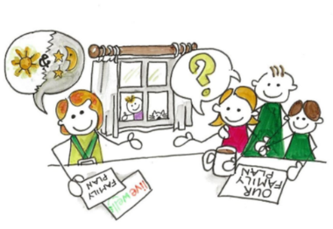

- Early Help Assessment link to Signs of Wellbeing and Live Well Pages for Early Help
- Neglect Screening Tool
- Graded Care Profile 2
- Contextual Safeguarding Screening Tool
- Contextual Safeguarding Assessment Tool
- Toxic Trio – with links to Domestic Abuse, Substance Misuse and Adult Mental Health
- Home Conditions assessment

EARLY HELP
When would you use it?
We offer Early Help when families need some additional help and support to keep their children safe and well. Early Help support is provided by professionals from a range of services across the partnership.
Every Local Authority has its own arrangements for early help assessments; some use CAF others use different assessments – but they are all similar. It has been agreed across the North West authorities that each LA will accept other authorities’ forms. So, for example if a child lives in Middlewich but attends a school in Winsford (Cheshire West) and someone from the school starts a CAF using the Cheshire West forms, we in Cheshire East will accept those documents. Similarly, if a SENCO at a school in Wilmslow wishes to do an Early Help assessment for a child resident in Cheadle (Stockport) who attends Wilmslow school then Stockport would accept the Cheshire East paperwork.

What is it?
In Cheshire East, we use Signs of Wellbeing at Early Help to make sure that children, young people and families are at the centre of decision making, as families are the experts on what works for them.

Where is it?
Click on this link Early Help - support and forms for professionals to access
- Early Help Assessment Form
- Early Help Plan
- Early Help Closure Form
Guidance is also available to support you completing each section of the form

NEGLECT

NEGLECT SCREENING TOOL
When would you use it?
When you have concerns that a child may be neglected. The first step in working with neglect is identifying those children who may be at risk and being able to provide the evidence base for this. Concerns at this stage may have arisen from a one-off event (e.g. a young child being left unsupervised), a concern over a change in behaviour or presentation of the child, or it may be that concerns have been building over time.

What is it?
The neglect screening tool will allow you to document what may be small, un-dramatic pieces of information and collate this into an overall picture of a child who is being neglected. This tool should be used to help identify and seek relevant information from any other involved agencies.

Where is it?
Follow this link to the Neglect screening tool

GRADED CARE PROFILE 2
When would you use it?
Graded Care Profile 2 (GCP2) helps professionals measure the quality of care being given to a child. It is an assessment tool that helps them to identify what may be putting that child at risk of harm. The original tool was developed by Dr Srivastava, a consultant pediatrician in South Yorkshire. The NSPCC worked with Dr Srivastava to develop the only authorized update of the tool. Graded Care Profile 2 is true to the original model but more user-friendly and comprehensive. It's important we identify children who are at risk of harm as early as possible so we can get them the right help. In Cheshire East as part of our Neglect strategy we are committed to agencies using this tool to evidence their concerns.

GCP2 shows:
- Strengths
- Weaknesses
- What needs to be changed?

By working out what parents are struggling with, it is expected that the person working with a family will be able to get them the right support to improve the life of their child.

What is it?
Professionals are specially trained to use the tool. They visit families at home to do an assessment with them, through conversation with them, which is a bit like filling in a questionnaire. It's called Graded Care Profile 2 (GCP2). The tool covers different aspects of a child’s care:
- Physical, such as quality of food, clothes and health
- Safety, such as how safe the home is and if the child knows about things like road safety
- Emotional, such as the relationship between the carer and child
- Developmental, such as if a child is encouraged to learn and if they a praised for doing something good.

Where is it?
Access to the GCP2 SharePoint site is allocated once you have completed the GCP2 Training.

The Cheshire East Safeguarding Children’s Partnership run regular workshops throughout the year to train staff to use the GCP2 tool. In order to access this training, you will need to complete the online nomination form which can be found by accessing the following link.
How to apply for a training course (cescp.org.uk)

CONTEXTUAL SAFEGUARDING
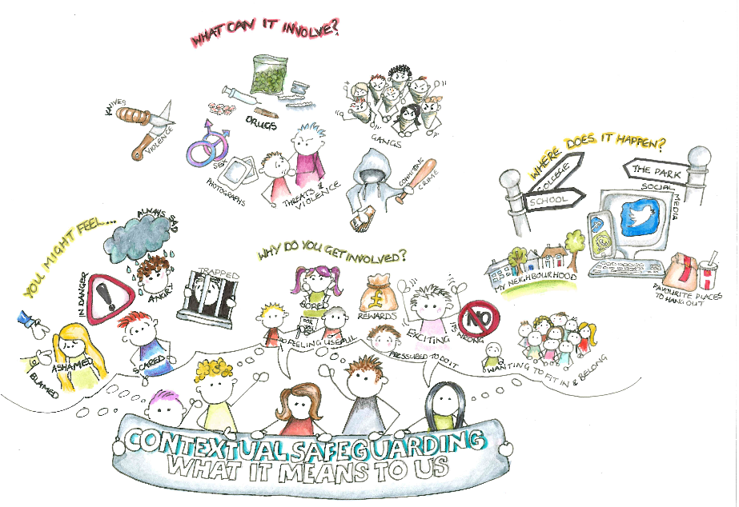

SCREENING TOOL
When would you use it?
Whenever you think the child may be at risk of sexual or criminal exploitation because there are a number of indicators worrying you. The screening tool is designed to help identify possible risks of exploitation and for you to be able to evidence and explain what you are worried about. Your observations of behaviours and any significant changes will be important. Significant changes in behaviours, a single high-risk episode or multiple risk factors may indicate that the child is a victim of abuse through exploitation rather than a teenager experimenting with risk taking.

What is it?
Where child sexual exploitation, or the risk of it, is suspected, all frontline practitioners should complete the screening tool to inform their judgement.

If, following the completion of the screening tool you consider that you can manage this within your agency, you should discuss with your manager/safeguarding lead and the carer and child and agree with them what you are doing to help and support them.

If the screening tool and following discussion with your manager/ safeguarding leads identifies for you that the child is at a level of risk that requires further assessment or intervention, you should seek parental consent and contact ChECS on 0300 123 5012 for a case discussion.

Practitioners should then forward the screening tool via secure email to the ChECS mailbox - checs@cheshireeast.gov.uk

The absence of consent should not prevent the contact being made where the risk for the child is significant. For out of hours please contact the Emergency Duty Team on 0300 123 5022.

Where the threat is immediate it may be appropriate to inform Cheshire Police on telephone number 101 or if necessary, through the emergency number 999.

This is an initial screening tool, and not a risk assessment. Please complete as fully as possible. The list of questions and observations within this screening tool is not exhaustive. There is an assessment tool that allows for more detailed understanding of the risks for the young person. If you think the risk is significant for them this tool should be used (see below)

Where is it?
Follow this link to the Contextual Safeguarding Screening Tool

CONTEXTUAL SAFEGUARDING ASSESSMENT TOOL
When would you use it?
The Contextual Safeguarding Assessment Tool should be used by all professionals working with children where they consider there is a significant risk of exploitation of a child. Use of the assessment tool gives a better understanding of the factors in the child’s life and context, that are increasing the risk or supporting safety and resilience. It should be completed with the child and the parent with their consent and shared with them.

What is it?
This is a risk assessment tool. Exploitation does not always involve physical contact as it can also occur through the use of technology and can include CSE, modern slavery, human trafficking, radicalisation and extremism and criminal exploitation.

Some of the indicators will be part of normal teenage behaviours and it is the presence of higher risk factors or multiple other factors which may be indications of exploitation. However, for younger children the presence of any one high risk factor may be a potential indicator of exploitation.
Professionals need to exercise their professional judgement when completing the assessment tool.
This includes capturing concerns about which they have some evidence AND concerns based on their “gut feelings”. Staff should differentiate between the two and explain this in the notes section.
Professionals should feel free to use the tool creatively, including as part of awareness raising work with children or in engaging parents and carers in understanding the issues.

They should discuss the finding with their manager/safeguarding lead to agree the next steps for the family (see above)

Where is it?
Follow this link to the Contextual Safeguarding Assessment Tool

CHILD SEXUAL BEHAVIOUR
When would you use it?
When you are concerned about a child displaying sexual behaviours that are inappropriate or potentially harmful and therefore in need of an initial assessment.

What is it?
This innovative resource helps professionals who work with children and young people to identify, assess and respond appropriately to sexual behaviours. It uses a 'traffic light tool' to categorise sexual behaviours, to increase understanding of healthy sexual development and distinguish this from harmful behaviour. By identifying sexual behaviours as green, amber or red, professionals across different agencies can work to the same criteria when making decisions and protect children and young people with a unified approach. This resource has been designed to help professionals think through their decisions and does not replace organisational procedures or assessment frameworks.

Where is it?
Follow this link to Stop It Now! to find the traffic lights.

RESILIENCE AND VULNERABILITY MATRIX
When would you use it?
When you are concerned that there are a number of factors in a young person’s life which are interacting to contribute to their current vulnerability or resilience.

What is it?
This tool is for use by all professionals working with children and families. The resilience and vulnerability tool will support analysis and decision making, without replacing professional judgement. This tool has been developed from the matrix to assist professionals in determining the right course of action. It supports professionals to focus upon the impact of identified factors upon the child.

This tool is intended to support consistent professional decision making based on evidence. If at any time practitioners have information that leads them to believe that a child is at immediate risk of significant harm, they should take action according to Cheshire East safeguarding procedures.

Where is it?
The resilience and vulnerability matrix is accessible via this link.

MULTIPLE SAFEGUARDING STRESSORS (TOXIC TRIO)

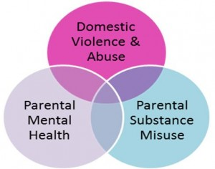

The past few years have seen an increased awareness of the frequency with which domestic and sexual violence, substance use and mental health problems co-exist. Various terms have been used to describe the concurrent experience of these three issues: the ‘toxic trio’, ‘the trilogy of risk’, and people with multiple and complex needs. There is concern that terms such as the ‘toxic trio’ are problematic because they can lead to the parents – most often the mother who is frequently the victim of abuse herself – being deemed toxic or seen as the main source of risk, and therefore they risk avoiding an understanding of each individuals situation and the impact of the experienced they are having on their capacity, or holding the perpetrator of domestic abuse to account for their behaviour.
Any combination of needs may be complex, supporting families affected by these three issues involves exactly that – talking explicitly about domestic abuse, substance use and mental ill-health and helping them to address the impact that these issues are having on them and their family.
Living with mental health problems, using alcohol or drugs, or experiencing domestic abuse does not automatically mean a parent/carer is unable to safeguard their child(ren) from serious harm. Adequate support can reduce (although not necessarily eradicate) the risk of children experiencing long-term negative effects of growing up with such problems. Children can achieve good outcomes when living in families where these factors are present. This is particularly true where only one issue affects the family.
So, identifying all three issues and how they impact on the adults and children present in any family is vital. Furthermore, professionals need an in-depth understanding of how the issues interlink – particularly in terms of what domestic abuse is and how victims may end up using substances as a way of coping with their experiences – to ensure the interventions that are put in place are as effective as possible in promoting the safety and wellbeing of all members of a household. Practitioners will need to use each tool relevant for the individual to establish a holistic picture.

DOMESTIC ABUSE
When would you use it?
The relevant tool should be completed when you know a child or young person is living in a household where there is domestic abuse.

What is it?
There are a range of Domestic abuse assessment tools to assist in making a decision about the impact for children and young people. This includes tools for:
- children and young people
- victims
- those who harm
The appropriate tools should be used where there is domestic abuse and to guide any decisions about safeguarding.
Where is it?
All tools are available on the Tools and Resources page for Live Well Domestic Abuse Pages.

CHILD TO PARENT VIOLENCE
When would you use it?
Where child to parent violence (CPV) and Adolescent to parent violence (APV) have been identified as a significant safeguarding issue.

What is it?
Tandem was developed as a group intervention for parents and children where child to parent violence (CPV) and Adolescent to parent violence (APV) have been identified as a significant safeguarding issue.

Where is it?
The material is currently available in these attachments

Please follow these links for the
1 | Tandem toolkit - Resources for Professionals working with Child to Parent Violence
2 | Adolescent violence to parents – A resource booklet for parents and carers
3 | Child to Parent Violence - A resource booklet for parents and carers

SUBSTANCE MISUSE
When would you use it?
If a parent has admitted to using drugs, to support you judging whether this is causing a risk to the children?

What is it?
The Parental Substance Misuse Guide is for use by all professionals working with children and families. It is part of a set of quick checklists which balances the factors that affect risk to the child. It can be used to assess the level of risk posed by parental substance misuse and provide guidance on referral route and future action planning for the family.

Where is it?
Please follow this link for the Parental Substance Misuse Assessment

There is also useful advice at the Change, Grow, Live website.

ALCOHOL MISUSE
When would you use it?
If a parent has admitted to using alcohol, to support you judging whether this is causing a risk to the children. It can be used to assess the level of risk posed by parental alcohol abuse and provide guidance on referral route and future action planning for the family.

What is it?
The Alcohol Screening Tool is for use by all professionals working with children and families.
It is one of a set of quick concise assessments on Substance Misuse, Domestic Abuse and Adult Mental Health

Where is it?
Please follow this link for the Alcohol Screening Tool
There is also useful advice at the Change, Grow, Live website.

ADULT MENTAL HEALTH
When would you use it?
When you are concerned that adult mental health is having an impact on children

What is it?
There are two tools for use by all professionals working with children and families the Anxiety and Depression one is to explore how serious are these issues for the adult and the Parental Mental Health Assessment is to explore how do these difficulties impact on a child.

Where is it?
Please follow this link for the Anxiety and Depression Screening and Cheshire East Parental Mental Health Assessment

