Cheshire East Safeguarding Children’s Partnership
TRAINING NEWSLETTER
Welcome to our APRIL 2024 edition Training Newsletter, bringing you a
HUGE variety of inspiring and accessible learning opportunities,
helping to boost your practice confidence, knowledge and skills.
COURSES: Register using Teams links to access WEBINARS and to book IN PERSON course places
APRIL | Weds  17th |  | Safeguarding Children with Disabilities |  | ON-LINE  WEBINAR | Register here to ACCESS Safeguarding Children with Disabilities *WEBINAR*
 | Thurs  18th  2-4pm  OR  Fri  19th  10-12 |  | Pan-Cheshire event:  Savera UK is working to end ‘honour’-based abuse (HBA) and all harmful practices, through direct interventions and safeguarding, advocacy, education, engagement, awareness-raising and campaigning for policy, attitude and behaviour change. Join a morning OR an afternoon session to find out more. |  | Teams INVITE for  On-line learning | *REQUEST A PLACE*  Contact: CESCPtraining@cheshireeast.gov.uk
 | Weds 24th |  | Cheshire & Merseyside Perinatal and Maternal Health: Lunch & Learn |  | Teams INVITE | See attached flyer for booking
 | Thurs 25th |  | Working Together 2023: summary update |  | ON-LINE  WEBINAR | Register here to ACCESS *NEW* Working Together 2023 *WEBINAR*
 | Tues 30th |  | Harmful Sexual Behaviours and using the ERASE tool |  | IN PERSON  Oakenclough Family Hub | Register here to ATTEND HSB & ERASE *IN PERSON* at Oakenclough Family Hub
MAY | Weds 1st |  | Complex Neglect |  | ON-LINE  WEBINAR | Register here to ACCESS Complex Neglect *WEBINAR*
 | Thurs 9th |  | Pan-Cheshire event: Responding to Sexual Assault & Violence |  | ON-LINE  WEBINAR | *SAVE THE DATE*  Registration opening soon!
 | Fri 10th |  | Professional Curiosity, Critical Thinking and Challenge |  | IN PERSON  Oakenclough Family Hub | Register here to ATTEND Professional Curiosity *IN PERSON* at Oakenclough Family HUb
 | Weds 15th |  | Contextual Safeguarding & Serious Organised Crime: An Introduction |  | IN PERSON  Crewe Municipal | Register here to ATTEND the CS SOC course *IN PERSON* at Oakenclough Family Hub
 | Tues 21st |  | Trio of Vulnerabilities |  | ON-LINE  WEBINAR | Register here to ACCESS Trio of Vulnerabilities *WEBINAR*
 | Thurs 23rd  10-2pm |  | Fundamental Safeguarding |  | ON-LINE  WEBINAR | Register here to ACCESS Fundamental Safeguarding *WEBINAR*
LOOK OUT FOR CHAMPS SUICIDE PREVENTION TRAINING IN MAY – FLYER ATTACHED
JUNE | Thurs 6th  9:30-4 |  | Child Protection Processes |  | IN PERSON  Oakenclough Family Hub | Register to ATTEND CP Processes *IN PERSON* at Oakenclough Family Hub
 | Tues  11th  9:30-4 |  | LADO – Managing Allegations |  | IN PERSON  Macclesfield Town Hall | Register to ATTEND LADO *IN PERSON* at Macclesfield Town Hall
 | Tues 18th |  | Signs of Safety and the Multi-Agency Assessment Tool |  | ON-LINE  WEBINAR | *SAVE THE DATE*  Registration opening soon!
* JUNE SPECIAL GUEST EVENTS *
June 13th | Online Safety Live: explore latest guidance on digital safeguarding for children.  Also see attached flyer |  |  | IN PERSON  Oakenclough Family Hub | Online Safety Live - FREE Tickets, 09:30-11:30 | Eventbrite  Online Safety Live - FREE Tickets, 13:30-15:30 | Eventbrite
June 26th | Pan-Cheshire event: Centre of Excellence on Child Sexual Abuse: ROADSHOW |  |  | IN PERSON  FRODSHAM | Save the date – Registration opening soon!
ON-LINE SHORT sessions at mid-day:
Delivered via automatic invite for your convenience: *NO BOOKING REQUIREMENT*
You will find further information on each topic embedded in your invite.
APRIL | Thurs 25th | LCSPR updates: Partnership essential learning for everyone - a timely update on all the latest news from your Local Safeguarding Children’s Partnership
MAY | Weds 8th | How to… Complete direct work understanding that children have diverse needs
 | Thurs 30th | LCSPR updates: Partnership essential learning for everyone - a timely update on all the latest news from your Local Safeguarding Children’s Partnership
LOOK OUT FOR MORE DATES AND TOPICS COMING SOON
E-LEARNING:
- CESCP modules are available via the Cheshire East Council Learning Lounge facility. To access these please follow this link or, log-in if you already have a Cheshire East email address at:
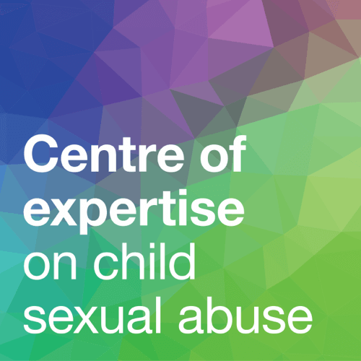
E-Learning (cescp.org.uk)

- Centre of Expertise on Child Sexual Abuse: This national organisation provides a range of FREE webinar e-learning opportunities as well as linked resources and tools: eLearning | CSA Centre

Look out for the Centre of Expertise ROADSHOW coming to Cheshire East on 26th June 2024!
More FREE Learning Resources:
  - The Children’s Society offer lots of free on-line resources on Child Exploitation here: National Exploitation Resources by The Children's Society
  - Explore CoramBAAF’s website to find a range of free resources, and they offer low-cost webinars that are also free to attend for members:
Free events | CoramBAAF

Please also find attached a useful tool for thinking about how we might approach difficult conversations with children and the language we use…
And finally….
If you would like to see any multi-agency practice topic to support shared learning opportunities adding to our training programme, or you know of a great resource or service that you’d like to widely share, please contact us at: cescptraining@cheshireeast.gov.uk

HOME: Cheshire East Safeguarding Children's Partnership (CESCP)
Courses available and links to book (cescp.org.uk)

