Date |  | Issue

Headline

Sub headline

For all children and young people, neglect has a cumulative effect over time and can be extremely damaging, and is potentially fatal. |  |  | 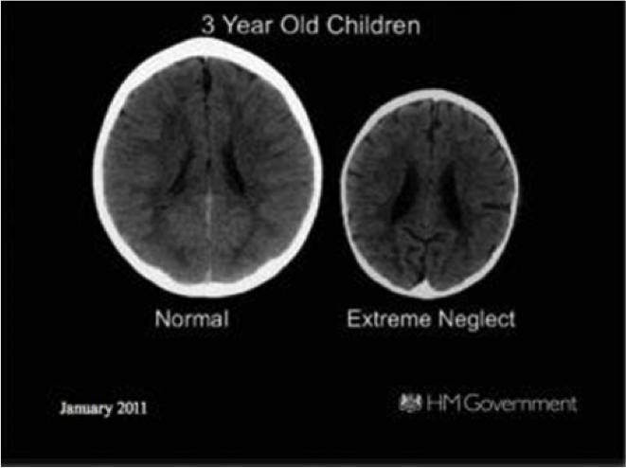
Headline

 |  |  | 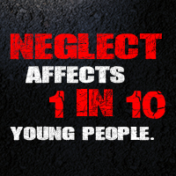
Quote

Headline

Quote

Headline

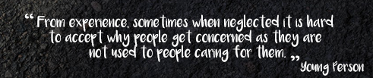

Headline

