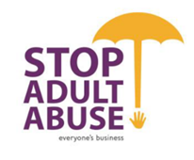  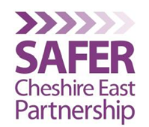

Cheshire East Contextual Safeguarding Strategy

“Trapped and you haven’t got a clue”



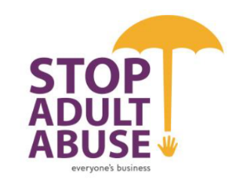  

**TRAPPED AND YOU HAVEN’T GOT A CLUE**

**Cheshire East Contextual Safeguarding Strategy 2019/ 2022.**

**Forward by Cheshire East Safeguarding Partnership.**

In Cheshire East the Safeguarding Children Partnership (CE SCP), has made contextual safeguarding a key priority for action for the next 2 years. Exploitation and abuse of children, young people and adults in this way is not new, but national research and local experience has illustrated that the traditional responses and child protection system is inadequate and inappropriate for safeguarding those whose experience of exploitation and abuse is extra-familial. This presents a challenge to all partner agencies and requires a system change to better safeguard this group of children and young people and to support our front-line staff to implement new approaches. It also requires effective partnership with services that are not traditionally linked to child protection, including housing, community safety and environmental services. This work, led by the Children’s Safeguarding Partnership, will feed into and influence the strategies for these services so that we have shared delivery priorities across Cheshire East for tackling violence, vulnerability and the exploitation of our children and young people.

We recognise that there are specific risks and vulnerabilities faced by children and young people who have Special Educational Needs and Disabilities (SEND) and this is reflected in the scope for this strategy. We have also adopted a ‘whole family’ support model as parents, carers, communities, and social networks are key players in ensuring that risks are managed and reduced and that our support is effective.

All partners, statutory and third sector, need a collective commitment and response to this change if we are to be effective in responding to this risk and supporting young people and their parents/carers. This includes the development of shared principles, language, attitudes and beliefs and a consistent practice framework. This is reflected in this strategy, the challenge over the next 2 years will be in its implementation, as we recognise that professionals will be required to work differently, beyond the framework that is outlined in statutory guidance and required to demonstrate innovative thinking and confidence to address the factors which may be causing harm.

In writing this strategy we have followed the principles of TOGETHER, ensuring we have consulted, co-produced and evaluated with children, young people and their families. The most common feeling expressed by young people, was the feeling of being trapped and their view that the professionals who are there to help often ‘didn’t have a clue’ about what is happening in their lives. For this reason, this is the lead title for this strategy. We set out how we can release them by understanding their experience and then acting with them and their family/ carers, to safeguard them.

Signed by

Signature of the Independent Chair for the CESCP 

Gill Frame Geoffrey Appleton Jill Broomhall

(Independent Chair of CE SCP) (Independent Chair of LSAB) (Chair of SCEP)

**Contents**

|  |  |  |
| --- | --- | --- |
| No. | Heading | Page |
| 1. | Definition and scope |  |
| 2. | Trapped and you haven’t got a clue – young persons definition |  |
| 3. | Vision, principles and aims |  |
| 4. | Contextual safeguarding and child protection |  |
| 5. | What we know about the contextual safeguarding profile  National picture  What young people and parents say  What local experience tells us |  |
| 6. | Common language |  |
| 7. | Listening to the voices of young people with SEND |  |
| 8. | Understanding the risks and impacts |  |
| 9. | Operational model – a single multi-agency route  Practice framework  Those most at risk |  |
| 10. | What front-line practitioners and managers tell us |  |
| 11. | What multi-agency audits tell us about our practice |  |
| 12. | Priorities |  |
| 13. | How will we do it and what will be the impact |  |
| 14. | How will we know |  |
| 15. | Appendices:   1. Understanding trauma 2. Effective practice with young people 3. Reflective supervision 4. Template for contextual safeguarding meetings 5. Risk mapping exercise example 6. Progressive stages for children and young people groomed for criminal exploitation 7. Operational flow chart for child exploitation 8. Assessment Tool & Screening Tool |  |

1. **Definition and scope**

Contextual Safeguarding is not a new phenomenon, but it is an **approach to understanding, and responding to, young people’s and young adult’s experience of significant harm that lies outside their families**. It recognises that the relationships that young people and adults at risk form in their neighbourhoods, schools and online can feature violence and abuse. These risks are a safeguarding issue, but need us to work with the young people as our partners in their own safeguarding but **never** responsible for their exploitation. (adapted from Firmin 2017).

Contextual safeguarding includes child sexual exploitation, missing children, gangs, county lines, radicalisation, modern slavery and all forms of criminal exploitation. There are clear links across these areas and it is vital that people, whether professionals or members of the public, know what to look out for and how to respond. It also recognises that the child’s experience of exploitation can undermine their relationship with their parents and that the child’s abuse is often beyond the control of their parents/ carers.

As with all abuse, there is an imbalance of power within the relationship which marks out an exploitative situation. Technology can play a part through its use to record abuse and share it with other individuals or as a medium to access children and young people in order to groom them. Research has shown that where children and young people have been coerced or tricked, blackmail has been used as a strategy by perpetrators to continue the abuse.

Some work with young people at **Sandbach High** and **Fermain Academy** gave the following definition; it’s about, ‘’understanding and responding to young people's experiences of harm and harassment (including online, sexual, physical, emotional) when this happens beyond their families (e.g. in friendships, out and about and understanding that relationships other than family can bring harm to young people and even death or self harm’’.

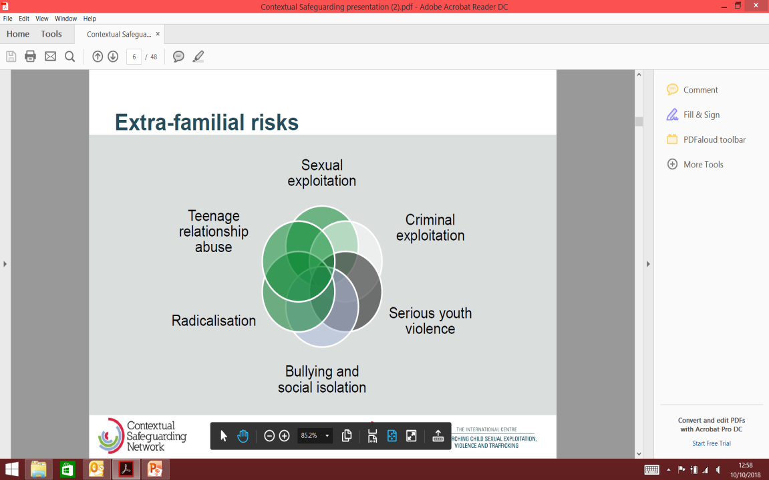

In Cheshire East the operational model for contextual safeguarding applies to, **criminal and sexual exploitation (including peer to peer exploitation and youth violence), trafficking, including those young people who go missing, and modern day slavery**. There are already systems within Cheshire East that shape our response where there is teenage relationship abuse, Forced Marriage, bullying and radicalisation. This strategy draws on the learning and effectiveness of those and is linked with them.

Cheshire East also recognises that the age of 18 is a constructed cut off point. Harm and the effects of it do not end abruptly at 18, but support and intervention can. Research and longitudinal neuroimaging supports the understanding that risk taking behaviours, and the impact of peers, commonly associated with adolescence, does not end at 18. The adolescent brain continues to mature well into individuals late twenties. This reinforces the need for effective transitional safeguarding arrangements to continue beyond the established cut-off point. Whilst it should be noted that Mental Capacity Act legislation will apply from this age, the commitment to offer support in line with this strategy will not change. It has been agreed that in **Cheshire East this strategy and the approach it sets out, will include young adults at risk to the age of 25,** after that point, adult facing services will consider their ongoing role and the longer term support and plan they may need to have in place, in line with their criteria**.** A protocol for support through this transition underpins this strategy.

1. **‘Trapped and you haven’t got a clue’, Young Person definition**

The term ‘contextual safeguarding’ does not mean anything to the young people we work with. We consulted with young people in Cheshire East to collate an explanation that was meaningful to them and this is what they told us:

When young people talk about this form of harm to them, they use different words and phrases. This makes it important that those working with them and supporting their family, check out the meaning of what they are saying.

They talked about the sense of excitement that they feel and that the help and support that was offered as an alternative path for them did not always compensate for the loss of this.

They were open about the financial rewards that their activities brought them set against a belief that this was within a context where they saw no economic future for themselves. We know for many of these young people access to an education has been a significant gap.

We have taken their words and represented them in a more graphic way so that children and young people, their parents and carers have a shared understanding with those working to support them. This is the result:

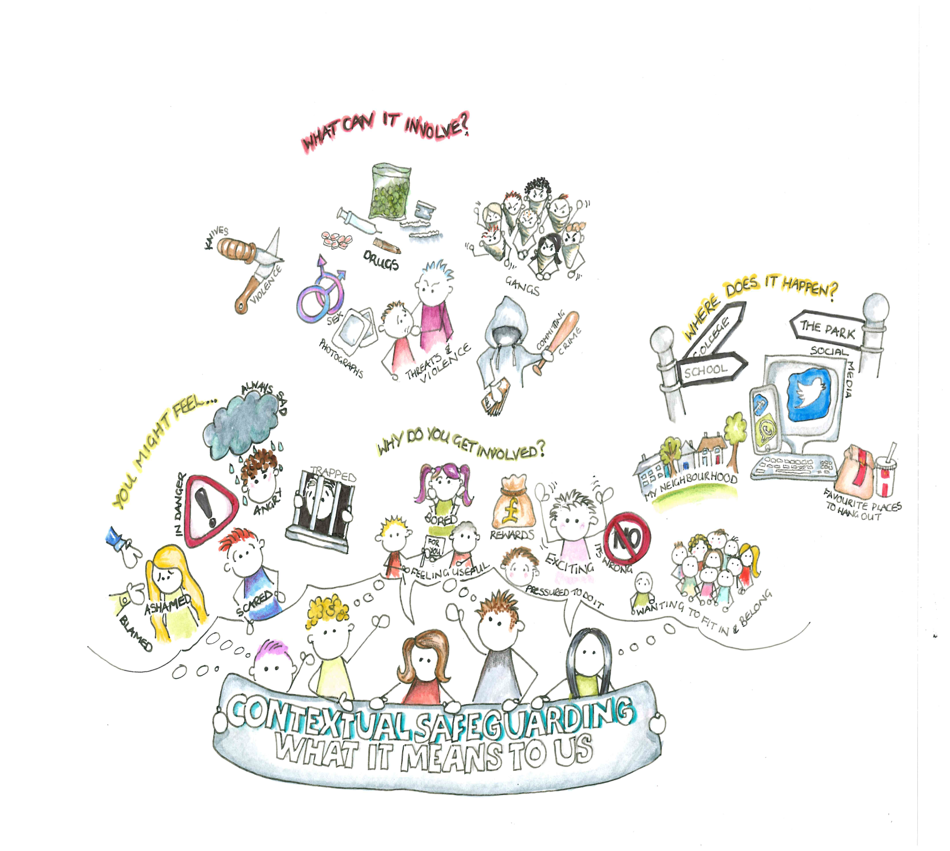

1. **Vision (what we want to achieve), and principles.**

|  |
| --- |
| *The vision in Cheshire East is that all children, young people and adults who are vulnerable to exploitation will receive the multi-agency support they need and a plan that reduces the risk that addresses the context that is causing harm. This also includes the action taken to disrupt and detain the perpetrators who exploit and abuse them.* |

Principles:

* The young person will be always be at the centre and a partner in their safeguarding plan, harm and risk reduction will happen with the young person.
* Contextual safeguarding is complex and therefore we recognise that the response cannot be linear
* All partners will understand the young person as being exploited, for which they are not responsible; we have a common language, understanding and application of the child welfare/adult safeguarding system first and juvenile justice system second. In this way extra-familial risks can be reduced through a child protection lens. For example; if we find a young person in possession of weapons or drugs, we will ask ‘what are the vulnerabilities for this young person?’ and ‘has this young person been criminally exploited?’ and assess the risk of exploitation when considering the response to them.
* The Partnership expects mandatory reporting on concerns about the risk of gangs, child violence, child labour, sexual and criminal exploitation and repeat episodes of children going missing.
* Young people in Cheshire East entering adulthood will not experience a ‘cliff-edge’ in terms of support, there will be no differences between thresholds / eligibility criteria of children’s and adults’ safeguarding for this cohort of young people (from 10 to 25 years) and the support will exist for as long as the need does. From the age of 16 decisions will be informed by and in accordance with the Mental Capacity Legislation where appropriate.
* Partners will enable young adults to live full independent lives where they can have confidence in their decision making, but also recognise the potential for coercion and control.
* We will make best use of every, and any, opportunity to engage with young people and their family and offer support, and we will keep offering help whilst the young person is unsafe. We acknowledge that single agency episodic interventions will not be effective, there fore we will be joined up.
* All partners will share information effectively to enable an assessment of risk and inform a response that ensures the best outcomes for the young person and the contextual risks. Schools and colleges in particular are essential partners in our whole-system approach.
* Intervention will reflect a trauma informed, strengths based, relationship focused approach that builds up rapport and trust with the young person and their family and responds in a joined up way to the whole child, their friendship groups and whole family/ community. The assumption is that interventions will be most effective when they are relationship based. ( see appendix ii)
* All partners recognise that child exploitation can have traumatic impacts on the wider family; parents/ carers need to be supported and not feel ‘blamed’, the focus of work with them will be to develop strategies together that help them to keep their family safe. In order to do this we will ensure that plans are developed in equal partnership and reflect the needs of the **whole family**.
* Effective services require resilient practitioners and all partners will ensure this within their agency, including the use of reflective and group supervision (see appendix iii)
* The Partnership understands that for young people there are sometimes significant financial rewards for the young person and excitement that drives their view that they are not being exploited. In acknowledging this, ways to replace those feelings in safe ways will be a focus of support as will our hope and ambition for their future.
* Services will respond to the whole of the young people’s needs; practical i.e. education, a home, a job, as well as physical, emotional and psychological
* Services will be able to respond together to rapidly changing risk.
* Partners will engage with and consider risk factors linked to the outdoor public realm to ensure identification and assessment of risk and to facilitate environmental design and actions to mitigate these risks.
* It is likely that children, young people and their families/ carers become ‘experts’ in understanding the risks and what is effective. The Partnership will recognise this, and actively seek feedback to improve and develop services and where possible develop peer support networks for both parents and children.

To achieve this, our aims over the next 2 years means we will:

* Reduce the vulnerability of young people in their community to contextual exploitation and build community resilience
* Identify early where a young person is at risk of exploitation
* Understand the additional needs and risk for young people who are also SEND
* Ensure that practitioners are able to identify, assess and act upon, the indicators of exploitation.
* Ensure an effective, coordinated multi-agency response at the earliest opportunity to protect and support young people involved in, or at risk of exploitation, including those at high risk.
* Ensure a ‘whole family’ approach by providing the right support for parents, carers and the young person’s safe social network
* Ensure the effective disruption, arrest and prosecution of offenders so that activity encourages the local community, protects children and young people, builds trust in individuals to report crime, discourages and disrupts criminals, and reduces crimes.
* Ensure that transition from child to adulthood safeguarding is seamless and ensures the young person and their family continue to receive the support they need and that this is reflected in the thresholds / eligibility criteria for children’s and adults’ transitional safeguarding.
* Work across Police force areas to ensure effective communication and information sharing about Cheshire East children, and develop a consistent approach, using modern slavery and trafficking legislation to target gangs, individuals and groups that exploit children to, work, transport and sell drugs.

1. **Why it’s important and different – contextual safeguarding and child protection**

In 2018, the Department for Education published the revised *Working Together to Safeguard Children*, which includes attention to adolescents who are “vulnerable to abuse or exploitation from outside their families”. Inquiries into serious failures in Rotherham, Rochdale and Oxfordshire led to a national focus on improving our understanding of and response to the complex risks faced by young people. The Children’s Society report, Counting Lives published in July 2019, indicated that ‘’the number of 10 to 17 year olds arrested for intent to supply drugs had gone up by almost 50% outside London’’. It suggests that ‘’the criminals are winning, and professionals are struggling to keep up with the scale and context of criminal exploitation’’. They say the response from statutory agencies is too variable and often comes too late; children are being too easily criminalised, and are not viewed as victims of exploitation. They have evidence that there is a lack of data and reporting about children at risk of criminal exploitation.

All young people are likely to have vulnerabilities at some point during their adolescence, for some, this makes them a target for exploitation. The risks arising from situations outside the family interact with a wide range of needs such as social exclusion, poor physical and emotional health, barriers to learning, and SEND. Adolescents with SEND may remain dependent as they transition to adulthood, with a small group remaining totally dependent on others for their safety and wellbeing. These risks for all young people are different from those managed through the traditional child protection process in the following ways:

* often manifest in extra-familial environments including schools, public spaces and online platforms
* are informed by peer norms and relationships, and the dynamics of some peer groups may increase the risk that an adolescent, for example, adolescents with SEND can be marginalised or be the focus of peer on peer abuse
* involve young people perpetrating, as well as experiencing, harm
* can present as the result of perceived ‘choices’ a young person has made and/or continues to make, despite professional/parental intervention i.e. repeatedly going missing from their home, going to ‘unsafe’ spaces. (see appendix viii)
* often feature grooming, coercion, criminality and serious risks of significant sexual and physical harm that create a climate of fear and reduces engagement with services
* some adolescents with SEND may be at additional risk outside the family home or setting due to their specific needs and abilities
* risks are often beyond the control of, and rarely instigated by parents
* can lead to large numbers of relocations including children coming into care for the first time and following a rapid escalation in risk and/or managed-moves across or out of schools including into alternative provision.
* continue into adulthood and particularly for young people during the 18-25 transitional period

A contextual safeguarding framework is required that addresses these external risks and reduce the harm they cause to young people, their families and within communities as they do not fit into the traditional child protection processes.

The University of Bedfordshire have developed a framework built on social theory to assist partners in understanding how they need to develop and organise services and systems differently in order to safeguard these young people effectively. The contextual assessment framework can be represented by this diagram.

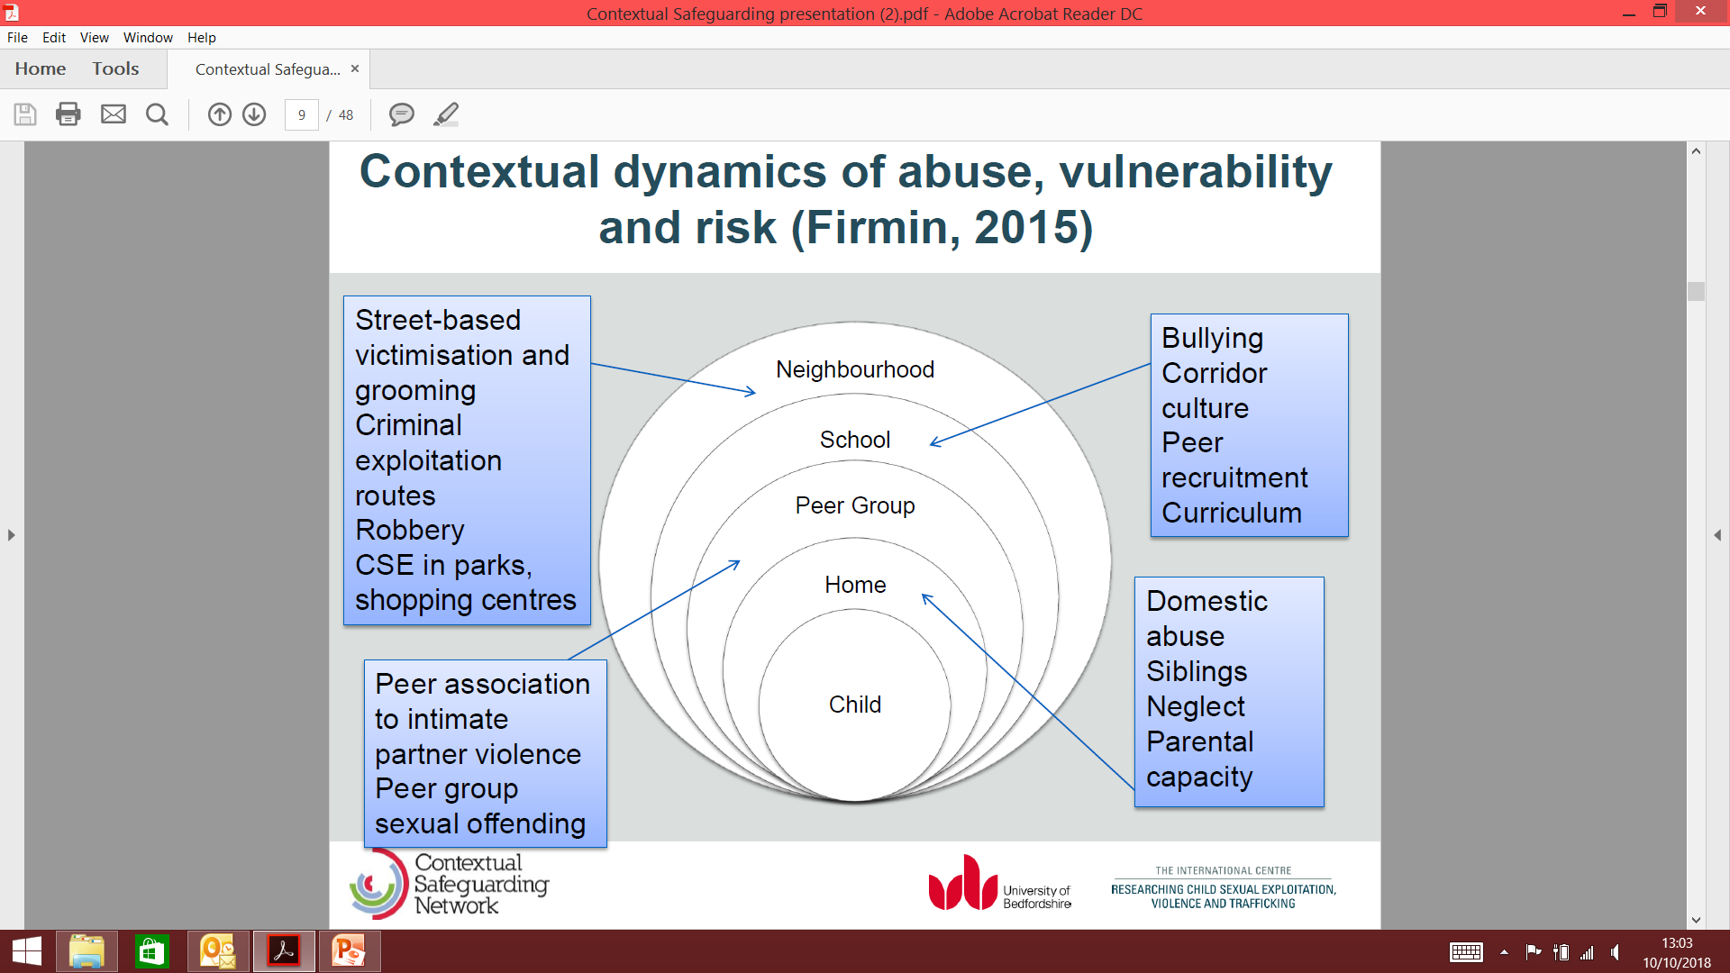

This model has shaped this strategy.

When operationalised a Contextual Safeguarding framework allows an area to do two things which feed into one another:

1. **Recognise contextual risks** **during child and family work**: record contextual issues related to referrals for children and families; collect information about extra-familial risks during child and family assessments, and; where extra-familial concerns are identified, refer these in for their own consideration (as below)
2. **Address contextual risk**: Accept referrals for peer groups, schools and public space; screen these referrals against contextual thresholds; subject them to assessment (and identify if they are a context in which children are in need of support or experiencing significant harm); discuss this assessment at a multi-agency safeguarding meeting, and; action a plan to reduce the risk in these contexts. These actions feed back into the individual child and family assessments/plans for young people affected by that context.
3. **What we already do and know – profile national and local**

There are a number of data sources for understanding the profile for contextual safeguarding in Cheshire East; however we need to be alert to the fact that the nature of this exploitation and abuse means that we are unlikely to fully represent the scale of the problem through data gathering. It is useful to be conscious of the factors that can indicate potential as well as clearly assessed and identified cases.

The results from a national police survey in 2018 suggested:

Results from a national survey in 2018

National data would suggest that Serious Organised Crime affects more UK citizens, more often, than any other national security threat; and that it is increasing in volume and complexity. Drug supply, firearms, modern slavery and human trafficking all feature in the profile for serious organised crime in the North West. Exploited child and adult drug runners and users are at the highest risk of violence, and in the North West over 10% are aged under 17.

Recent (October 2019) coordinated police activity across Force boundaries to disrupt county lines activity, led to the arrest of over 700 people, the disruption of 49 ‘deal lines’ and the safeguarding of 292 children and young people. This emphasises the need to shift the way that agencies work together.

We know that the further ahead an area and partners are with having an awareness and response to contextual safeguarding the higher the recorded numbers of children and young people are recognised as being exploited and abused in this way.

During 2019 the Safeguarding Children’s Partnership led a learning review, which involved a young person who was criminally exploited with tragic consequences. The findings have been fed into the first national practice review, which focused on adolescents in need of state protection from criminal exploitation.

The profile, patterns and common factors that emerge include:

* The age commonly ranges from 14 onwards, with a peak in the 15-19 year age group
* In most cases (81%), the weapons used are knives
* The significant home and parental characteristics were; parental separation, domestic abuse and substance misuse and criminality within the home
* The vulnerability for the young people were characterised by; criminality with drugs, knives and missing reports
* Most of the young people (88%) were excluded, in a Pupil Referral Unit, an alternative provision or had no school or were Not in Education, Employment or Training (NEET).
* For the 66% of children known to children’s services, a third were receiving services as Children in Need
* The most common route children were first identified as being at risk of Criminal Exploitation was through the criminal justice system, which is too late.

The profile and themes for those identified in the youth justice system in Cheshire:

* Exploited children were often from transient families who’ve moved several times or where the young people have been moved
* Poor physical, mental and emotional health is common. Some young people had histories of numerous A&E admissions following quite serious injuries due to violence. Many have some contact with mental health services.
* There is evidence of drug dealing that began around the age of 13, usually well before first conviction and child known to the youth justice service but there was a real reluctance (fear) among young people of opening up to professionals about this
* Journey of the child shows most had some periods of stability following statutory intervention (e.g. Child Protection, YJS order) but these tended to be relatively short lived and children can become gradually more entrenched in organised criminality and swiftly move from victim to groomer to perpetrator of serious violence against other children.
* The National Referral Mechanism (NRM) process is inconsistent and some referrals portray exploited children as perpetrators. Evidential threshold for child trafficking appears to be so high that children exploited and obviously in fear of violence not considered ‘trafficked’ and being convicted of Possession With Intent To Supply (PWITs)
* An intervention/support gap for Cheshire appears to be in respect of parallel work needed with parents/wider families (i.e. whole family support while child is receiving direct intervention)

There are few surprises in the themes that emerge. Knives exist in every home and are therefore easily obtained. The risks for children exploited in this way change quickly and the assessment and their status of need may not fully reflect the risks and vulnerabilities that impact on them. The significance of the education provision needs to inform how services are targeted to support this cohort of young people to prevent and reduce exploitation.

**What children and young adults and their families and carers tell us**

The views of our children, young people and their families/ carers have been instrumental in shaping this strategy and acting as a critical friend to our sense of what we need to do and what works.

Overwhelmingly young people have told us that ‘**you haven’t got a clue’**. They consider that we often know little about the truth of their lives, they are reluctant to talk to us and we often engage with them at a superficial level. Exclusion from school can escalate risks rapidly and where there are delays in providing an alternative provision the vulnerabilities increase. This is similar for those children who are on reduced/ part-time timetables where the children remain part time for an extended period of time with no plan for returning to full time education or provision for the hours they are not in school. (refer to appendix v)

Whilst moving children out of the area (either a care placement or moving a family), can provide some immediate removal from the risks, it does not last long and it creates pressures and gaps through separation from families and safe support networks. Removing whole families also impacts on their support and can have financial consequences. We are not always recognising the role, expertise and response that can be gained from housing providers. We need to support families so their young people mature, and become equipped for adulthood. This means empowering them to live full and independent lives and exploring all available accommodation opportunities within their local communities.

One of the key factors that both parents and young people thought helped was the opportunity to talk with those who have experienced the same things.

‘’*You’ve got to want to change, other stuff is pointless. I’ve come to realise that violence isn’t worth it. I think chatting to other young people who have done the stuff themselves’’.*

Parents were also keen that their child should be visible in communities as well as within agencies when they went missing*. ‘’ Put him on Facebook as missing so everyone can look for him. Parents messaging each other is good’’.*

**What our information currently tells us.**

The strength of practice in information sharing as experienced through child protection, acts effectively within contextual safeguarding to protect individual young people where we have concerns about them. However, one of the challenges for the Partnership will be in the development of a system that can reflect our profile to inform our understanding of the victims that are being targeted, the connections across peer groups, the origin of the perpetrators and their typology and the places that we need to make safer. At present the system does not support this type of intelligence sharing and analysis that may direct preventive action.

The local information provided by individual agencies tells us the following about the experience of contextual safeguarding in Cheshire East.

The Youth Justice Service flag children within their service identified as at risk of exploitation (across the whole YJS cohort including both Divert and court ordered children). This indicates that at least **1 in 5 (20%)** children in the youth justice system have been flagged as being at high risk of criminal exploitation, and strongly suspected of being under the control of an organised criminal group, and therefore in need of a contextual safeguarding response. For Cheshire East, these are not children unknown to services; they live with their families but have experienced a significant number of moves, often lived with violence both inside and outside the home, and have poor physical and emotional health including significant presentations to Accident and Emergency. The review of this cohort makes it evident that children and young people need earlier recognition of potential vulnerability and intervention.

There has been a fluctuating pattern of Child Exploitation screening tools completed to inform a referral to statutory services over the past 8 months, (see table below). The peaks have been linked to joint operations that have been identified through the operational meetings.

|  |  |  |  |  |  |  |  |  |
| --- | --- | --- | --- | --- | --- | --- | --- | --- |
| Month (2019) | **Jan** | **Feb** | **March** | **April** | **May** | **June** | **July** | **Aug** |
| Number of tools completed | 18 | 15 | 24 | 8 | 14 | 18 | 41 | 18 |

Currently, the Child Criminal Exploitation operational meetings would normally be discussing the potential risk for 18 children in the North of Cheshire East and 20 in the South, and there are commonly 8 children considered as being at high risk of CSE and therefore subject to a plan to manage the risk. There would commonly be 12 children discussed at the Youth Organised Crime group. There are inevitably more children who are in need where the assessment of risk is at a lower level, including those young people who engage with youth and prevention services.

In the North of the borough, children considered at high risk of exploitation are mainly female aged between 14 – 17 years from a range of ethnic backgrounds. The experience is of sexual exploitation. Other behaviours linked to this are Anti-Social Behaviour as opposed to Criminal Exploitation. The majority of the children in the North attend mainstream education and whilst there are challenges to managing their needs in school, they have largely been supported to remain in this environment.

In the South of the borough, the profile of children at risk of sexual exploitation includes both males and females. The girls range from 13-17 years old and the males from 15-17 years old. Young people at risk of criminal exploitation include males of both White British and Slovakian ethnicity and these young people have also been linked to the sexual exploitation of females. In the South of the borough, the majority of young people do not attend mainstream schools and are more commonly tutored ‘off site’ or attend specialist provisions. A position we are working to improve.

At the time of writing, since January 2019, there have been 3 joint Operations which have led to significant exposure of criminal and sexual exploitation of children in Cheshire East, involving perpetrators based in different cities in the country, and young people trafficked to Cheshire East from those areas. This has involved males and females.

There are believed to be multiple County Lines in the East and whilst there are no statistics to show how many of these teams are targeting under 18’s we know from the local Operations that under18’s are involved and we are currently an ‘importer’.

From police information from January 2019 to September 2019 there have been approximately 18 young people from the Macclesfield area and 35 young people from Crewe involved (arrested or subject of) offences that could be linked to Contextual Safeguarding, this includes drugs and sexual offences.

Within our ‘missing children’ statistics and profile, whilst more children are reported missing from home than care, those that go missing more than once are a much smaller proportion and are known to services. For example in a typical month (August 2019) for children in our care, 5 children represented 68% of the missing episodes, 3 of these were Cheshire East children; 3 of our children placed outside of Cheshire East went missing 3 times, and 5 children living at home represented 36% of the incidents. Some of these children are being exploited and abused by people outside their family. All of our children who have significant repeat episodes are all involved with services and have a plan to support the reduction in potential harm and risk to them.

For children exploited we know that with the strong rail links and the hub at Crewe, rail travel is noted regionally as the most predominant mode of transport.

Over the last 5 months, from April 2019 the multi-agency group which considers low level risk for children, persons of interest and locations have considered 25 children. Their average age was 14, and 56% are females where the risks relate mostly to sexual exploitation and the males relating mostly to criminal exploitation. This may reflect current recognition bias. For these children, after information sharing, 4 (16%) were escalated as high risk.

At August 2019, there are 9 persons of interest being considered, 55% of these are male. There are three locations where police are taking disruptive actions. The known high risk locations are managed through the joint operations.

There have been 12 referrals to the national referral mechanism (NRM) for under 18s since June this year but this information wasn’t held centrally prior to this so it is difficult to give a more accurate picture, this is coupled with difficulties in referrals being accepted with challenges to the threshold being applied nationally. It is also acknowledged that partners need to raise awareness with frontline staff and managers of the NRM.

Whilst there is little evidence available at this stage of community profiling in Cheshire East to inform the risks and resilience locally, the community safety delivery plan will link to the priorities within this strategy.

Beyond the data, there is always a child’s story that needs to be recognised, valued and learnt from. This is one child’s story:

*Dee is 13 years old; she lives at home with her mother and 2 siblings. Dee’s mother has a history of drug addiction and has significant mental health issues, and the family have been known to Social Care for a number of years. Dee finds it hard to understand or regulate her emotions, she did not have a trusting relationship with any adult outside her family and she gravitated towards her peers and the community. Police know Dee as one of a group of children on the edge of care and custody due to the anti-social behaviour she was involved with.*

*Dee was not attending an educational provision, she finds it hard to engage in learning and she worries about her mother, her younger siblings, and her future. As the oldest child, Dee is left to her own devices more than her siblings. This has included being out late at night in her community making her vulnerable and ‘easy’ to target and groom. Her family have not always reported her missing as they don’t always know that she has not come home.*

*In 2019, Dee was identified as part of a Police Operation regarding sexual and criminal exploitation; she had been a victim of sexual assault along with others. Dee had been forced to perform sexual acts on adolescents and adults and had been involved in low level drug dealing. Dee had no reason to trust social workers or police and did not consider them necessary to help her be safe as she saw no risk to herself. The adults exploiting her were seen by her as friends who ‘looked after’ her, gave her stuff and understood her.*

*The Partnership worked with Dee in a different way and established a multi-agency group around her, supporting her in a more proactive and intense way by building relationships, gaining her trust, increasing engagement and ultimately increasing her safety and understanding of risk and exploitation. The goals towards her safety were defined with her and at her pace so it was achievable. In parallel, support was provided to the wider family to help them understand what unpinned the behaviours for Dee and what they could do to develop a plan that helped reduce the risks for her. Over time (9 months), whilst Dee is still at risk, there is now a better understanding of that risk, increased engagement from her, a safety plan that has been developed with her and a trusting relationship between her and professionals that has been so positive that she now seeks people out when she gets worried and is allowing us and her family to help to keep her safer.  Dee will be transitioning back into full time education soon, taking small but significant steps in the right direction. The things that have made a difference are:*

* *Consistency of workers who stick with her even when she is abusive and aggressive who see her as a child who needs support and who she knows won’t give up on her*
* *Working with her at her pace with her still within her community and social network*
* *Looking at her whole needs*
* *Ensuring she shaped the plan to keep her safe, even when it felt less safe for professionals, and reviewing this regularly or when need arose to re-address the risks*
* *Support to the family where they understood that they were not to ‘blame’ for what was happening to their child.*

1. **Common language or meaning the same thing when we talk about it**

‘A different language is a different vision of life’. Federico Fellini

Previously, this strategy has outlined the Partnership scope and definition for contextual safeguarding in Cheshire East.

Historically there has been a way of focusing, talking and describing the behaviours of children and young people that denies them their ‘victimhood’ by blaming, and assuming choice and ‘lifestyle’. Previously, this has been enshrined in legislation, reflected in a societal view and has infiltrated organisational cultures.

It is vital that managers and practitioners choose accurate and neutral language to describe the behaviours of children and young people that demonstrate an understanding of constrained choice (refer to appendix i). Language choices must also reinforce self-efficacy, and emphasise the capacity of individuals to act independently and to make decisions about themselves and their care. There is growing national consensus through consultation with young people (e.g. Young Minds, The Children’s Society) that regularly describing them as “vulnerable” is patronising and diminishes the sense of adolescent agency or power.

There are a range of stigmatising words and phrases that reinforce the myth that young people are completely in control of their choices. For example the phrase “lifestyle choices”, ‘’putting themselves at risk’’ or ‘’in situations where they will be vulnerable’’, ‘’will not cooperate with’’ and ‘’sexually active with…’’, does not describe the constrained choice of young people who are being exploited. These phrases fail to recognise the factors that have prevented young people from being safe. Practitioners must reflect on how their attitudes and beliefs can act as a barrier that can prevent young people from accessing the support they need or shape the wrong sort of intervention.

To overcome these barriers and to maximise opportunities for young people to engage with services, practitioners must be aware of their own attitudes, values, beliefs, privilege and cultural positioning and the impact these factors may have on professional relationships.

Reflective supervision with managers or peers in a one-to-one or group setting can be an effective way to examine some of these factors and the effects they may be having in building relationships with young people.

This strategy requires the Partnership to eliminate language and responses that blame and stigmatise children, young people and adults at risk. Alongside this we need to act to reduce the gender bias reinforced by traditional approaches, particularly around harmful sexual behaviour, child sexual exploitation and gangs. The responsibility to achieve positive engagement between children and young people and services lies entirely with those services and their practitioners.

1. **Listening to the voices of young people with SEND**

All young people have a voice which deserves to be heard. Young people with SEND may face additional barriers to communicating and influencing decisions made about their lives. This may include those with:

* Speech, language and communication needs;
* Communication and interaction difficulties associated with severe and profound learning difficulties;
* Autistic Spectrum Disorders (ASD).

Working effectively for these young people may include using different strategies that enable to them to express themselves and understand others:

**Visual communication** including signs, symbols, photographs, objects can assist some adolescents to express themselves and understand others

**Adapting speech** to individual needs may be useful, such as simplifying grammar, using concrete terms instead of abstract or figurative language, and using short, clear phrases instead of longer sentences.

**An advocate** can support adolescents without formal language to have their voices heard. An advocate who knows them well will be able to interpret body language and other forms of potentially communicative behaviour.

**Assessment of mental capacity** and use of best interest decision making for those lacking capacity will support best practice with young people.

The responsibilities for contextual safeguarding within this strategy matches the age range for services for young people with SEND, from 0-25 years

All Partners agencies need to:

Know your agency policy on SEND, which will refer to the SEND Code of Practice 2015. Reflect: how can you adopt effective communication strategies to ensure the voices of young people with SEND are heard.

1. **Understanding the risks and impacts for young people**

In developing a local strategy, whilst it is important to have a shared definition and language, the implementation relies on ensuring a comprehensive understanding of the risks to young people that may indicate they are being exploited. As set out earlier, adolescence itself brings with it potential vulnerability. The Partnership needs to support practitioners across service thresholds and disciplines to be brave and innovative, to hold and manage those risks.

For young people with SEND, practitioners must be willing to hear the concerns of these young people. For those who are at an earlier developmental stage than their chronological age, the safeguarding concerns may be equivalent to those of younger children. Working effectively with young people with SEND may include using different strategies.

The risk for young people can range from being denied the opportunity to make their own decisions, being in debt, threatened, coercion to commit criminal acts including violence and abuse, to becoming victims of violence including serious injury, rape and death.

For young people affected by contextual exploitation and abuse they will have experienced trauma* and may be in a state of hyperarousal. This will impact on them in a number of ways, including their:

* Emotional, physical and mental well-being
* Behaviour - Involvement in offending, going missing, use of alcohol, drugs, etc.
* Family relationships adversely affected
* Ability to access education and other services adversely affected
* Willingness to trust and engage with adults reduced

Some of the characteristics may also be those commonly associated with the changes experienced through transition into adulthood, i.e. secrecy, mood swings, challenges to boundaries, disrupted sleep patterns.

The PAN Cheshire screening and assessment tools for child exploitation can support practitioners in determining if their worries require a contextual approach (see appendix viii)

* Trauma is defined as a psychological, physical threat or assault to a child or adolescent; physical integrity, sense of self, safety, and survival.

1. **Operational model**

As set out previously, there are two tiers that must coexist to ensure contextual safeguarding is effective.

At Tier 1 professionals wrap recognition of extra-familial context around all their work with individual children, young people and families, using this information to inform assessment and intervention decisions and plans with them. At Tier 1 the system needs to be capable of consistently recognising and responding to peer group, school, community and online risks that might be impacting an individual child and family. For example, recognition of extra-familial contexts should be evident in the considerations of the child and family assessment or in the techniques used to engage young people in discussions about safety outside of the family home and be reflected in the individuals plan.

At Tier two, professionals work to actively change the extra-familial contexts identified as impacting on young people and families – peer groups, schools, public spaces can be subject to an assessment, safeguarding meeting or plan. At Tier 2 the system needs to have approaches and tools at its disposal that directly engage with peer group, school, community and online contexts. For example, the case management system would need to be able to open a case on a peer group or school – as well as families – and record case notes against that context. The system would need to be able to assess these contexts and be able to build and deliver a plan to decrease risk and increase safety in these contexts.

While each tier will operate against a distinct set of enquiries, when a Contextual Safeguarding approach is being taken, the two tiers intersect and complement each other. A contextual safeguarding system is created when both tiers are identified as part of a whole child protection system. For example, an assessment and intervention plan for a local park where children are being exploited would need to be connected to all child and family plans in place for young people who are being exploited in that park. Likewise, should practitioners identify that risk to one of their young people has escalated in the park then they would need to notify the lead overseeing the assessment of, and plan for, the park to note this potential change.

The pictorial representation of how the operational model needs to work and the facets that are considered and weighted can be expressed as (Firmin 2015):

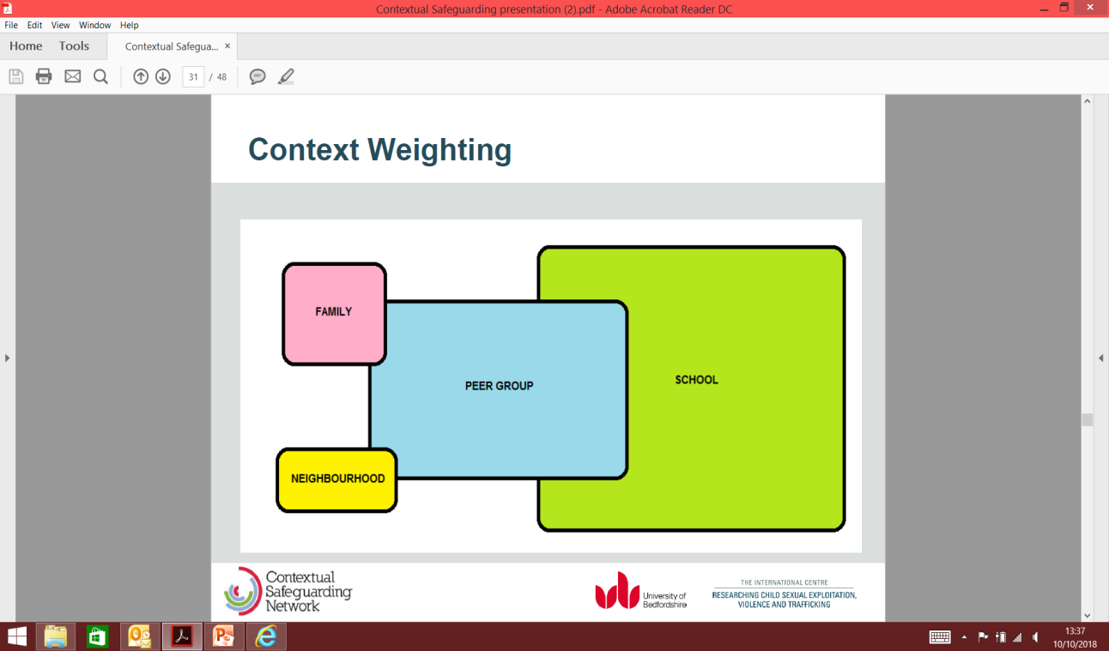

To achieve this we need to ensure that services who work in each of the contextual ‘spaces’ are well coordinated and informed.

This presents a challenge to the traditional intra-familial child protection model that organisations and their systems are shaped to respond to. For a multi-agency whole system model that supports contextual safeguarding significant changes will be required across the Partnership.

Local Position

There are currently a wide range of multi-agency operational meetings in Cheshire East at which a young person might be discussed. This can result in duplication and multiple plans all covering single elements of the child’s and family’s needs and agency response without addressing the collective contextual risks as they impact on the child.

The practice framework in Cheshire East will be to convene a single multi-agency **Contextual Safeguarding Operational Group** (CSOG).  All children with a completed Child Exploitation screening or assessment tool will, in the first instance, be considered at the weekly multi-agency meeting at the integrated front door (ChECS). Those identified as being at medium or high risk will come under the remit of the Contextual Safeguarding Operational Group, as will all children currently open to Navigate and Complex Youths and all children with an Anti-Social Behaviour Contract (ABC). The meeting will consider the risk identified by the lead professional.  Partner agencies will support discussions with **intelligence/information** from their individual services. The membership, terms of reference and recording process for this group are set out in the protocol document. The Operational Group will work to identify where a Tier 1 response (Contextual Safeguarding Safety Planning Meeting) is needed for an individual child, and collate intelligence and profiling and planning for a wider Tier 2 response. If a Safety Planning meeting is not required, but the child is still assessed to be at risk of exploitation they will continue to be reviewed via the CSOG.

The process is set out in the flow-chart in (appendix vii)

**Those children most at risk (Tier 1)**

For individual children at risk of exploitation, and their families the approach will be to ensure that multi-agency Safety Planning Meetings meet the following requirements:

* The starting position will be an understanding of the child as being exploited and likely to be experiencing trauma
* These will be the multi-agency meeting where all elements of the child’s influence, risk and needs within their context are understood and captured in a single plan (refer to appendix iv)
* They will include the child and their carer as partners in their assessment and plan
* The role of the peer group, educational setting, social network and community will be reflected in the plan to keep the child safe and will therefore require additional partners to those normally involved with a family where a child is at risk
* The group will respond rapidly to changing/ escalating risk to review the plan
* The meeting will consider the needs of the carers for support, and plan this with them
* The meeting will work on the principle of keeping the child and their family safe within their community and be informed by the risk map (refer to appendix vi)
* The safety plan for the child and family will be shared with the Operational Group to inform their Tier 2 intelligence and planning.

The operational framework is set out in the multi-agency contextual safeguarding procedure**,** and is underpinned by Cheshire East transitional safeguarding policy.

1. **What practitioners tell us**

The role of strategic leads across the Partnership is to ensure that practice is informed, robust and effective. In order to achieve this, it is critical to listen to the voices and experiences of children, young people and their families, but also our practitioners and managers. In developing this strategy, this is what they told us they need:

* All agencies to view children in the same way so we start from a place where they can be understood as victims of exploitation for which they and their parents/carers are not responsible
* Clear pathways to share concerns through a single route to a single meeting and joined up intelligence sharing
* Confidence in what good safety planning looks like for managing the risks and holding the risk
* Tools that help shape work with children who do not consider themselves to be exploited or in need of help and see no alternative to their life that will bring them rewards
* Creating the spaces where they can feel safe that include schools
* Understanding what disruption tactics can be used in planning interventions.
* Shared plans that tackle all elements of the risk, including to siblings and shared ownership of this
* Knowing where practitioners can go for advice and being kept updated with knowledge, skills and tools to support best practice
* Understanding effective use of the National Referral Mechanism (NRM)
* The time to develop the trusting relationships that are needed
* Understanding how communities can be developed with community ‘guardians’ so they can play a part in safeguarding

‘*We are concerned about the challenges we face in responding effectively where young peope are recruited (and paid) to deal/distribute drugs. Some of these young people, don’t recognise themselves as victims and can have quite a fatalistic approach and see this as their only prospect of earning money. The challenge is how to work with them as victims when they have a pro-criminal identity themselves’*. Youth Justice Service.

‘*Antisocial behaviour at parks and other public locations perpetrated by young people, needs to be better linked into the intelligence and risk assessment for young people within the contextual safeguarding context, and understanding and pathways to achieve this needs to be built into our operational model’* . Council Open Spaces Staff

‘*There is a need for a clear pathway for all relevant information to be shared in one place, so this is not fragmented and prevents the child being discussed and monitored at multiple meetings with slightly different remits. For front line staff it is knowing where to go for advice and building knowledge and skills supported by analysis of intelligence to inform risks’*. Police

‘*We need greater support in developing confidence in safety planning and holding the risk when removing the child from home is not the solution and there is a risk to other children in the family. Also having the right support and emotional resilience to manage the worry that these children bring to staff personally*’. Children’s Social Care.

1. **What audits tell us**

The issue of contextual safeguarding has some challenges for the effectiveness of traditional ways of working together. However at its heart lies a shared desire to protect children and young people from harm, and this is not new. We know that some of the things that can make a difference for families are:

* Approaching children and young people and their families as needing help and support at the earliest opportunity.
* Trusting relationships built over time
* Good communication and sharing information
* Holistic assessment and planning with the family as partners
* Whole family and community response

In Cheshire East we have audit evidence that shows good practice in ensuring that the experience and voice of the child is evident in assessment and planning; that agencies have a commitment to the multi-agency processes to keep children safe, and that adult behaviour is considered in terms of the impact for the child. There is evidence in working with children who are exploited of good and courageous multi-agency work with young people that have resulted in their protection and good outcomes. We are also aware of variation in the quality of our practice, together with opportunities where we can be more effective in consistent use of tools to evidence the impact of the action taken on the child.

The Partnership will conduct a multi-agency audit specifically focused on impact and outcomes of our contextual safeguarding model in 2020 to give baseline information on our practice that will inform the future priorities for action.

1. **What our strategic priorities are**

There are a number of fundamental changes that are needed in order to fully implement an effective contextual safeguarding model in Cheshire East. For this reason there is a need to prioritise and ensure that local activity is supported through PAN Cheshire activity where this make sense for Cheshire East children and families.

For this reason the implementation priorities are phased over the next three year period and are set out below. The governance for progress will be carried out through the relevant sub group to the Safeguarding Children’s Partnership and the priorities will be reviewed and agreed at a minimum on an annual basis.

Year 1 2019/20

|  |  |  |  |  |
| --- | --- | --- | --- | --- |
| Priority action | PAN/Local | Lead | Timescale | Outcome |
| Agree strategy | Local | CE SCP T&F group | November 2019 | There will be an agreed direction supported by the Partnership to improve the way that we respond to contextual safeguarding in Cheshire East |
| Establish operational model | Local | CE SCP T&F group | November 2019 | There is a clear pathway for young people who are identified at risk to be considered and safeguarded. |
| Masterclass for practice leads across agencies | Local | CE SCP T&T operational group | February 2020 | Agency leads are identified and informed, so practice is effective and consistent |
| Provide and launch tools to inform, screening assessment of risk level and planning | PAN | PAN Cheshire strategic contextual safeguarding group | December 2019 | Practitioners are confident about how they identify and assess the risk a young person may be at from contextualised safeguarding |
| Provide training for front-line practitioners and managers | PAN and Local | PAN Cheshire strategic contextual safeguarding group and CE learning and improvement sub group | January 2020 | Practitioners and their managers will feel confident in their understanding of the risks contextual safeguarding presents to children and young people and what a safety plan needs to address |
| Target learning and assessment for professional staff working with children who are excluded, in a PRU, or an alternative provision | Local | SCiES | March 2020 | This cohort of vulnerable children will have staff that have high levels of awareness and skills so they are prevented from becoming exploited, or the risk is identified early and the right help is sought. |
| Agree a transitional safeguarding policy for contextual safeguarding up to 25 years | Local | CE SCP and CE ASB | January 2020 | Children and young people who experience child exploitation will not experience a ‘cliff edge’ in provision at 18 but will continue to receive the services they need to keep them safe. |
| Structure service response to meet needs to 25 years | Local | CE SCP T&F group | March 2019 | Young people experience a seamless transition of service and support as they achieve adulthood |

**Year Two 2020/2021\***

|  |  |  |  |  |
| --- | --- | --- | --- | --- |
| Priority action | PAN/Local | Lead | Timescale | Outcome |
| Development of a meaningful profile of the facets of contextual safeguarding to inform service development, including community profiling | PAN and Local | PAN Cheshire strategic contextual safeguarding group and CE learning and improvement sub group | TBC | The collated information provides a clear profile and analysis of contextual safeguarding in Cheshire East and this is used to inform priority action. |
| Evaluation of the operational model and interventions | Local | CE SCP T&F group | TBC | The Partnership is able to learn from best practice to ensure the systems supporting that practice are in place |
| Establish a group of peer mentors for young people and parents who have had similar experiences | Local | TBC | TBC | There is an opportunity for parents and young people to feel supported and understood and develop techniques to manage and reduce risk that work for them. |

**\***please note the priorities may change depending on local changes

**Year 3 2021/2022\***

|  |  |  |  |  |
| --- | --- | --- | --- | --- |
| Priority action | PAN/Local | Lead | Timescale | Outcome |
| Align the community safety strategy to tackle violence, vulnerability and exploitation | Local CSP | Chair of SCEP | TBC | The operational activity for contextual safeguarding is supported within the strategic focus for building safe and resilient communities |
| Work with LL to develop a case record system that is able to meet the demands of contextual safeguarding | Local CSC | DCSC and Business Intelligence team | TBC | The case management system will be able to open a ‘case’ on a peer group or school – as well as families – and record case notes against that context. |
| Review the specific evidence of what works in makes communities safer and more responsive | Local | CE SCP T&F group  And community safety | TBC | The Partnership will be assured that the communities in Cheshire East are supported to safeguard children and young people at risk of contextual safeguarding |

**\***please note the priorities may change depending on local changes

**13. How we will do it and what will be different**

A multi-agency task and finish sub group to the Safeguarding Children’s Partnership has been established with an action plan which is over-seen by the Learning and Improvement Sub group. This sets out the activities to achieve the priorities.

The current task and finish group will need to develop into an implementation group with practice leads across the agencies to ensure that local and national learning informs service development and practice in a timely way

The implementation group will include partners not usually involved directly in traditional child protection including adult safeguarding, environment services and community safety.

1. **How will we know**

The measures of success will developed against each of the priorities within this strategy. For year one these are suggested as:

|  |  |  |  |
| --- | --- | --- | --- |
| Measure | Source | Lead | What will it tell us |
| The number of CE screening tools used to inform referrals will increase | Local Authority referral data | CSC | That practitioners are identifying risk and screening the level of risk a yp experiences so we have a higher level of awareness amongst practitioners and judgements of risk and need are informed |
| The number of assessment tools completed for CE increases | Local Authority data | CSC | The needs of children and young people at risk of CE are better understood. |
| The quality of completed screening and assessment tools improves | Young Addaction | Young AddAction | As practitioners become more confident at identifying child exploitation, they will understand the risks for children better. |
| The number of plans using the template (appendix iv) increases |  |  | The plans that shape the safeguarding of young people at risk of CE reflect the extra-familial factors and address them. |
| Number of professionals attending CE training and can demonstrate impact on their practice. | CE SCP | CE SCP Trainer | Front-line practitioners and managers gain confidence in understanding, assessing and responding to the risks presented to yp through CE |
| Numbers of yp with a CE plan transitioning into adult safeguarding services | Care leavers service and LSAB | CSC and  Sandra Murphy | There is evidence that young people continue to receive support and services to safeguard them where they experience CE. |
| Outcomes based measures  These will be supported through tracking the outcomes for a group of children who have received support to identify what worked and how good outcomes were achieved  Audit  Focus groups |  |  | Repeated CE tools  Audit of safety plans  Scaling reduces following intervention  Appreciative enquiry – What works  Number of children with CE plans who remain in fulltime education and attend provision  Feedback from young people once work completed and risk reduced.  Focus groups with YP who have had interventions and focus groups in schools  Focus group with parents/carers |

**Appendices:**

Appendix i.

Understanding Trauma and constrained choice

Research has shown that trauma has a significant impact on adolescent brain development. In general, trauma can be defined as a psychological, emotional response to an event or an experience that is deeply distressing or disturbing. Some young people will have a traumatic response to risk and/or harm that they have experienced.

Additionally, environmental stressors can add to children’s and young people’s adverse experience. Inadequate social support, stigmatisation (held responsible for the abuse), social marginalisation and oppression are likely to exacerbate psychological symptoms.

The young person’s exposure to adverse conditions produces a range of symptoms that have a profound impact on the cognitive, emotional, physical, and social development of the individual.

We know that brain development continues throughout childhood and adolescence becoming finalised during mid-twenties. Adolescence is a period of accelerated brain development characterised by the maturing of the prefrontal cortex which is linked to executive brain functions such as controlling impulses, multi-tasking, organisation skills, planning and making decisions.

The impact of trauma and the activation of the survival response i.e. fight, flight, freeze leaves an indelible imprint on brain functioning. These responses release stress hormones such as cortisol which at extreme levels can cause alterations in brain development and functionality.

Trauma becomes grooved and etched into the brain by neural pathways. Normal responses are predictable, formed from the firing and wiring together of neurones. This is a vital function of the brain and without this ability we would for example need to relearn how to walk every day. A similar process occurs with trauma which becomes encoded in the brain. The activation of the trauma response ensures the frontal lobes disappear and the individual becomes hard wired to the trauma response and danger. The brain switches to the ‘survival’ brain in a defensive and vigilant mode intent on detecting for threats and anticipating danger

Researchers suggest that for children and young people who are abused and neglected the areas of the brain connected to self-hood and relating to others, are compromised and do not develop to their full potential. This can manifest in the following ways:

* A diminished ability to interact with people.
* A lack of understanding of their internal emotional world,
* An inability to manage internal states
* The parts of the brain responsible for memory, reward and evaluation of punishment is impaired resulting in individuals who are dis-inhibited, show anti-social behaviour and do not respond to discipline
* The ability to make complex conscious judgements and plans is compromised
* The body’s reward system is compromised
* The capacity for healing, growth, rejuvenation, learning, self-soothing and self-development are adversely affected

*Constrained choice*

An understanding of trauma helps practitioners to recognise that rather than being completely in control of decision-making, young people often make **constrained choices** compared to others who can make choices, over which they have full control.

The choices of a traumatised young person are highly likely to be constrained. In some cases, due to the impact of trauma, a young person may not be in a position to make any choice at all. The impact can affect their belief system of the harm they would come to if they tried to leave the person and situation they are being exploited by.

Practitioners need to be aware that some young people may also have experienced trauma related to their SEND e.g. through prejudice from others, through failed educational placements etc. Young people with SEND may not be able to identify or communicate their traumatic experiences. Where communication is not effective, choices may be constrained e.g. the young person cannot express a wish not to take part in an activity or to associate with a peer.

Appendix ii.

Effective engagement with young people

Practitioners can fall into the habit of *doing an assessment to a young person* rather than **with** them. Our audits would tell us this is still evident in some of our practice in Cheshire East. The following basic guidelines support our effective engagement with young people informed by them:

**Listen, listen, and listen**: the single most important principle is to listen to what the young person has to say

**Acknowledge**: we need to be positive with the young person for being able to talk to you, what they have to say, and how you can support them

**Stay alert**: keep your eyes, ears and body language open to what the young person has to say, without judging, being shocked, commenting or advising (in the first instance)

**Start neutral:** do not discuss the consequences of their behaviour during early stages of engagement, unless there are clear and immediate familial child protection concerns

**What’s in it for me?** Listen out for motivation and to gain an understanding of what the young person wants.

**Solution-focused:** ask questions that lead to solutions, rather than remaining on problems, issues, and mistakes

**Be sensitive:** describe behaviours of concern sensitively, considering the pace and number of questions

**Adapt communication** to needs of young people with SEND or work with an advocate who knows them well

**Prepare for challenge**: lead the young person carefully towards for intrusive, probing or challenging questions

**Offer a way out**: explain to the young person that they can end a discussion or engagement

**Ready for change?** approach early engagements with curiosity and look for the signs of readiness to change.

**Feedback:** give feedback that is specific and focused on desired behaviours

**What’s your view?** Seek their perception of their behaviour rather than talking about your perceptions.

**The behaviour *not* the person:** there is much more to a young person than their behaviour. Be aware of your own emotional responses.

**Cut the judgemental phrases**: I am disappointed by you

**Avoid correction:** instead of questioning the decision, question how they arrived at their thinking

**Follow up!** Make sure that the plans you put in place actually happen through regular communication.

There are tools available for practitioners to support the work they do with young people that can be accessed on the partnership website:

<http://www.cescp.org.uk/professionals/contextual-safeguarding.aspx>

Appendix iii

The need for reflective supervision

Practitioners who support adolescents who have experienced trauma are at risk of **vicarious trauma**. Vicarious trauma is an aspect of any profession that involves caring for others and can be more acute for professionals who work with traumatised children and young people. Empathising with young people is vital but can mean that practitioners take on trauma.

To remain effective and to get the best possible outcomes for traumatised children it is essential to make sure that professionals working with them are resilient and have access to the support they need (Vicarious trauma: the consequences of working with abuse NSPCC research briefing 2013).

Good practice examples for actively supporting practitioners to prevent the onset of vicarious trauma and build resilience include:

* Providing reflective supervision, either on a one-to-one or peer group basis.
* Providing clinical supervision from an external organisation.
* Encouraging staff to consider self-care and strategies they can adopt outside of work to build their resilience.
* Encouraging staff to adopt firm work/life balance boundaries.
* Encouraging and adopting an environment/workplace learning culture that is open and discusses the impact that work has on staff’s wellbeing, feelings and emotions.
* Encouraging positive relationships between team members and across agencies and partners.
* Make employee assistance lines available to staff and ensuring staff know who they can access these

Appendix iv

Template for contextual safeguarding meetings



Appendix v

Safety mapping exercise from Hackney



Appendix vi

Progressive stages for Children groomed for criminal exploitation

Developed by The Children’s Society with young people in Manchester

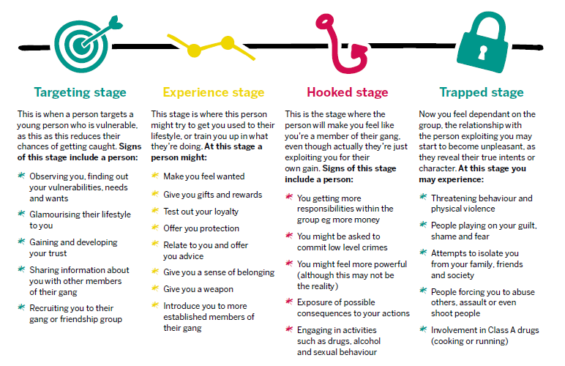

Appendix vii.

Operational flow chart for child exploitation

connective arrow

Intelligence of risk in place, community and planning

Discuss with manager/safeguarding lead

Make a referral

Yes

Are the criteria met for

referral to Children Social Care or Early Help Brokerage for further assessment?

No

Identification of associates/peers

Profile/diversion /disruption of perpetrator

Child exploitation safety planning meeting/S.47

Immediate risk of harm S.47 pathway

Assessment/monitor/support by lead professional

Contextual safeguarding operational group

Medium/High

All children

* Open to Navigate
* Complex Youth
* With Anti-Social behaviours contracts
* Concerns raised in place/environment

Children where:

* Repeated missing
* Episodes
* Missing over 24 hours
* Missing placed by other local authority

Low

Determined level of risk based upon shared information

Consider at weekly multi-agency meeting

Still concerns submit completed tool to ChECS

Lead professional completes child exploitation screening assessment tool

Child about whom there are concerns

Appendix viii.

 

*available on the CESCP website 16th December 2019